**SPLUNK**

**Splunk Beginner to Architect**

**Section 9: Indexer Clustering:**

1. **Overview of Indexer Clustering:**

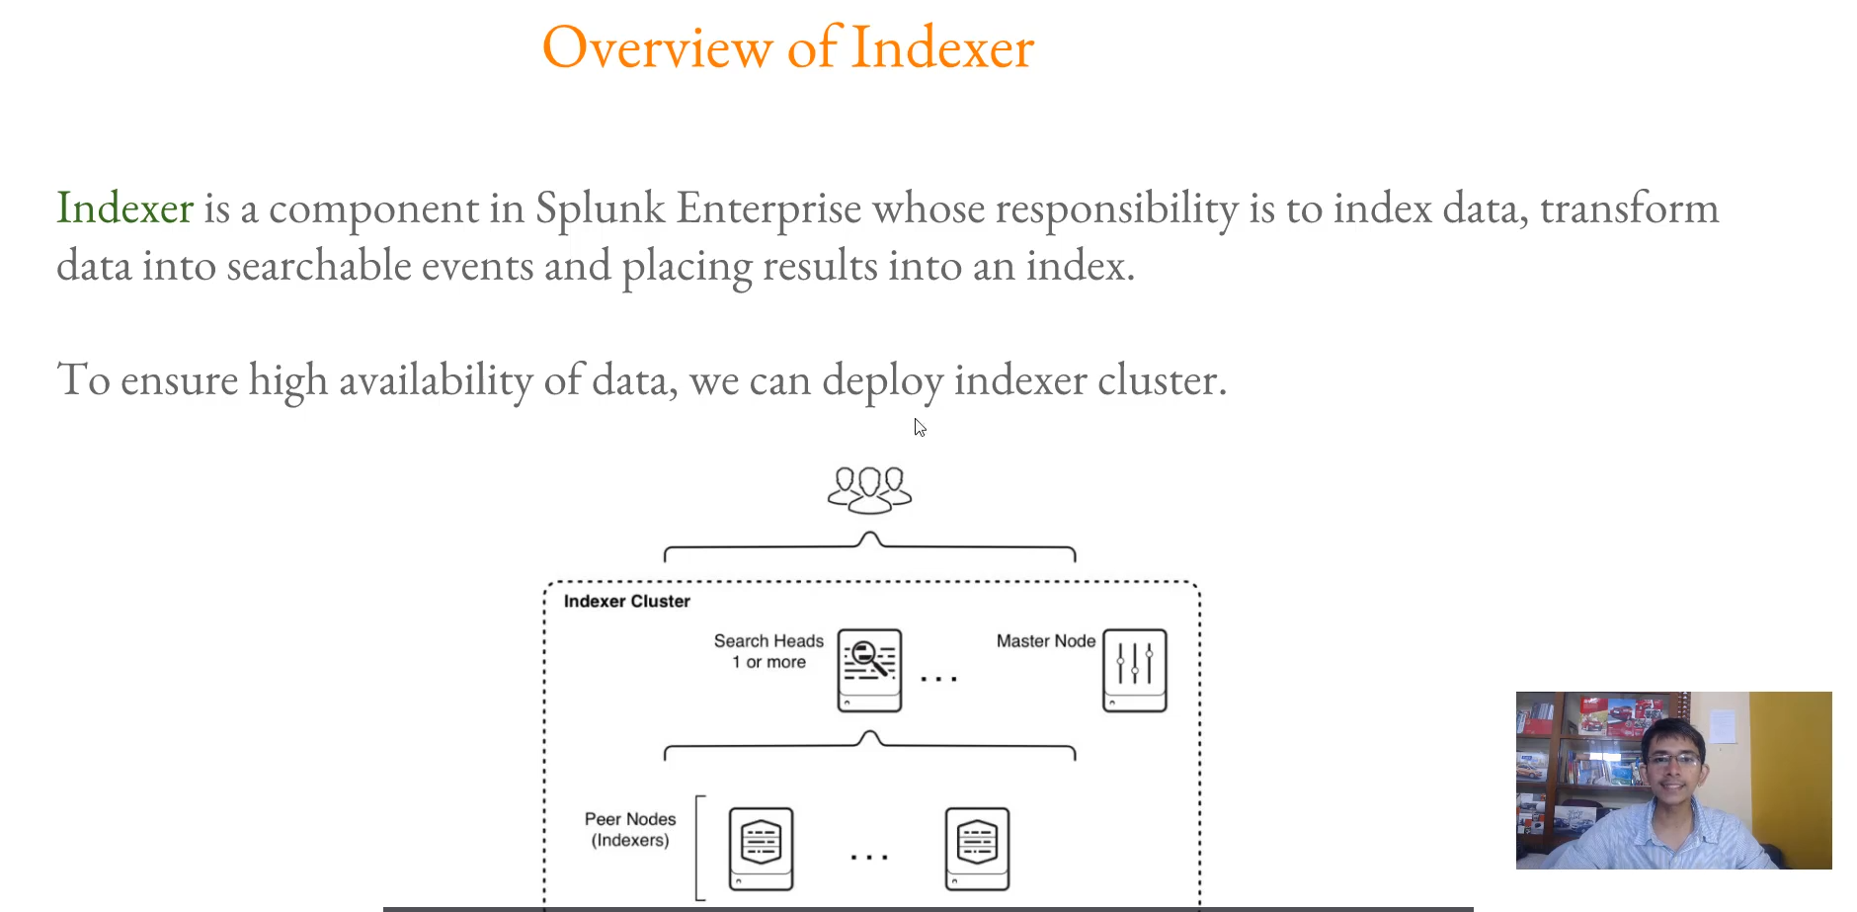

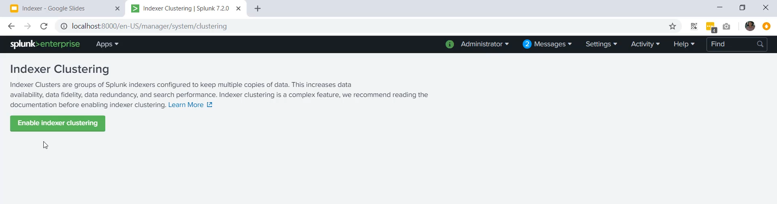

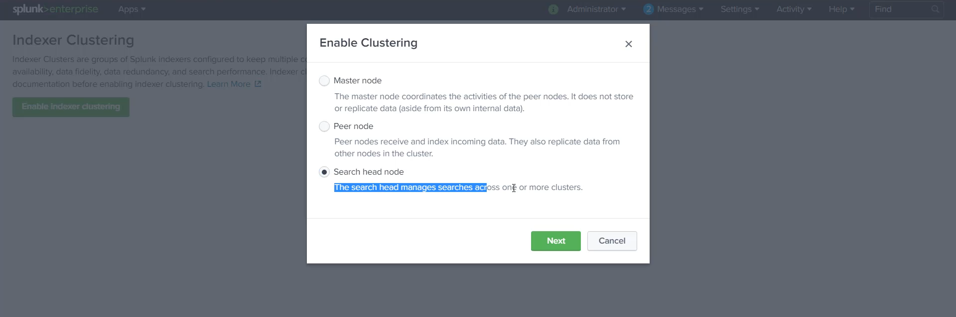

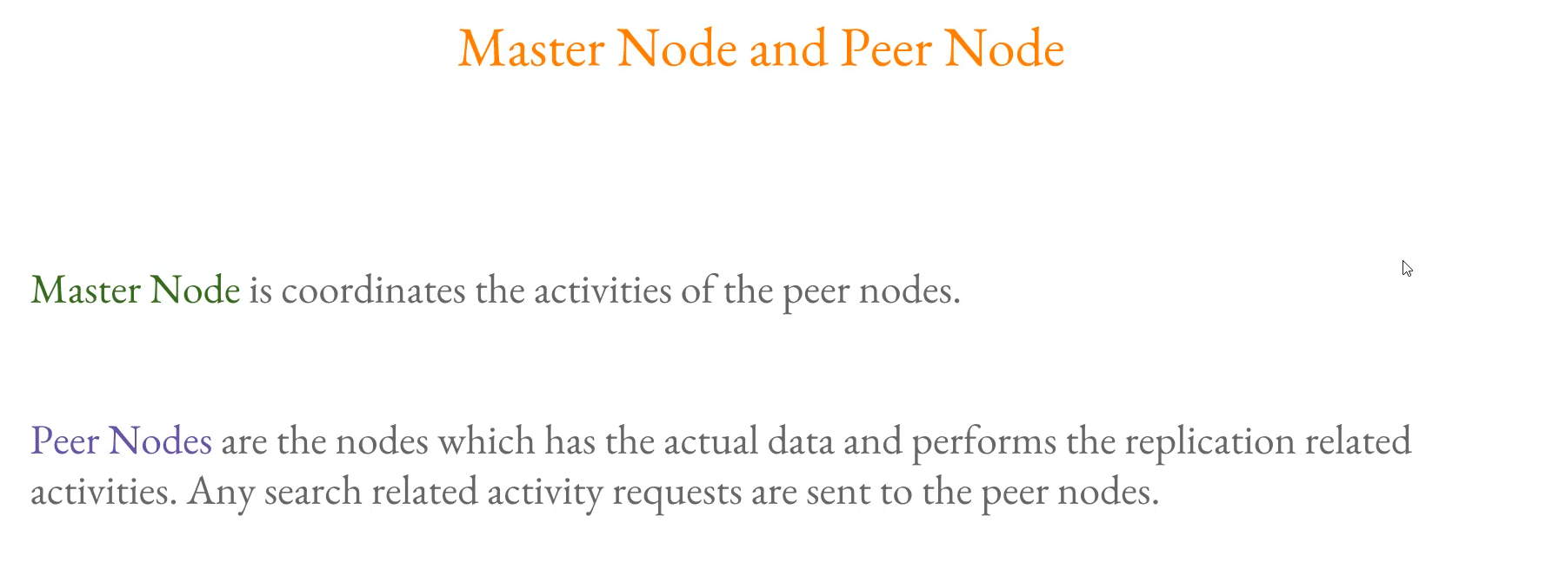

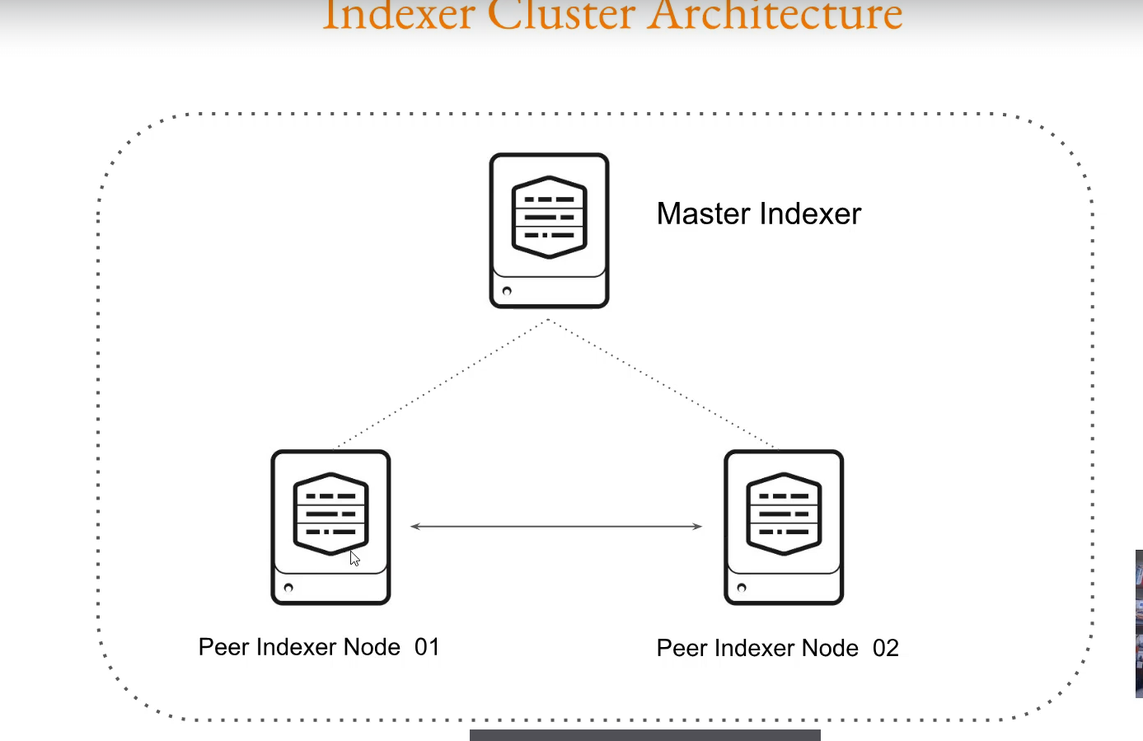

Key Takeaways on Indexer Clustering:

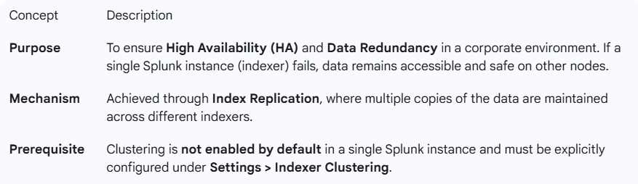

**Core Components (Cluster Nodes)**

The cluster consists of specialized Splunk Enterprise instances, each with a specific role:

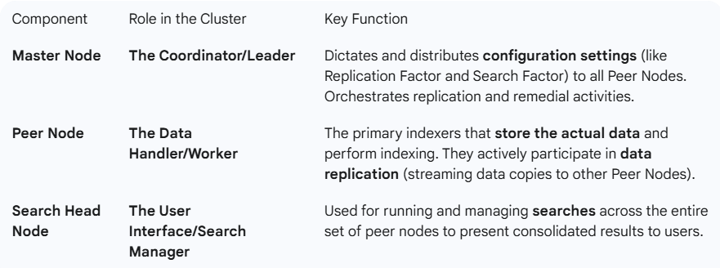

**Important Note**

As you correctly pointed out:

**The Master Node does not take part in data replication by itself.** Its sole responsibility is coordination and configuration management for the Peer Nodes.

**============================================================================**

1. **Infrastructure for Indexer Cluster:**

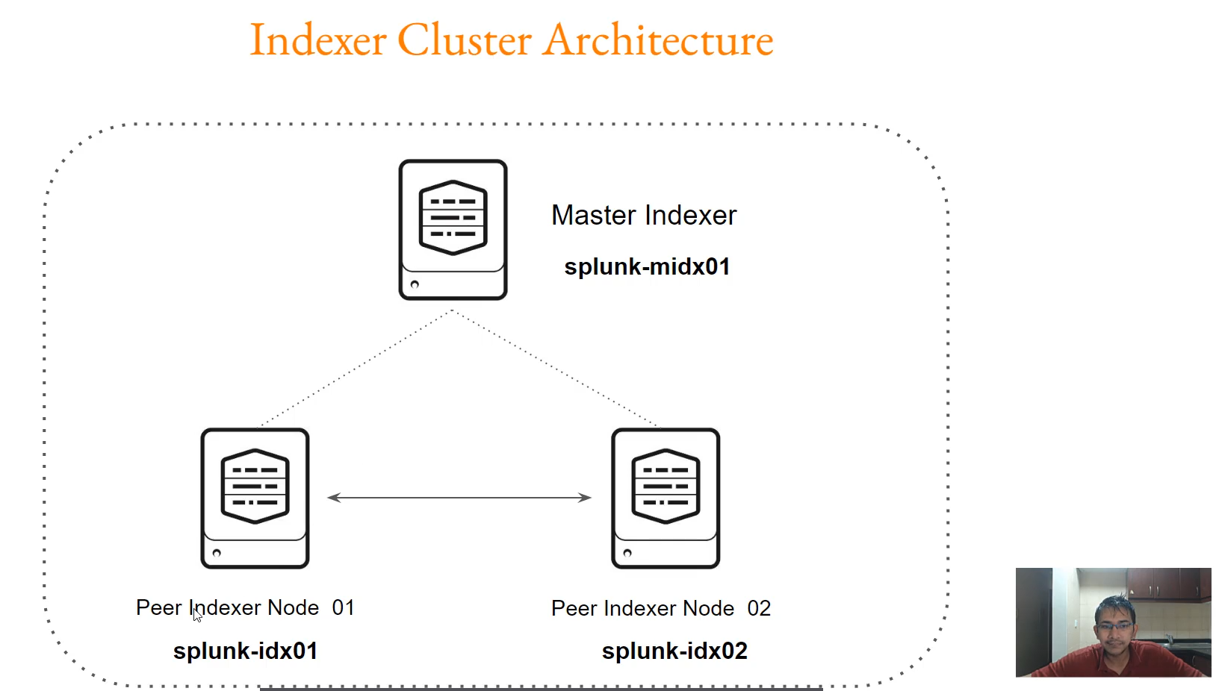

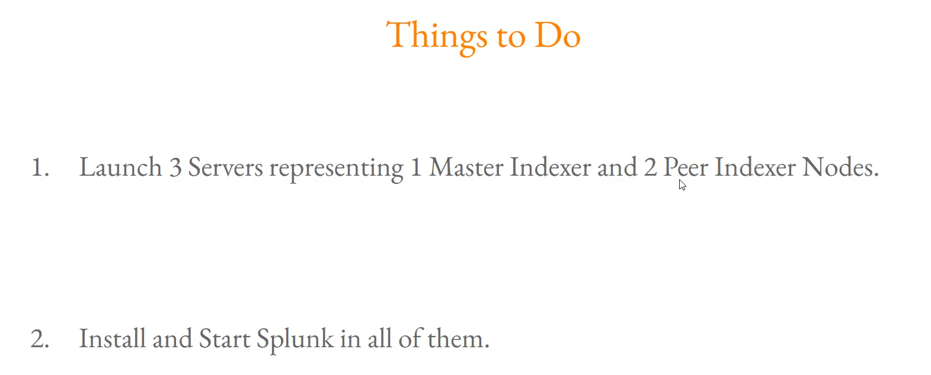

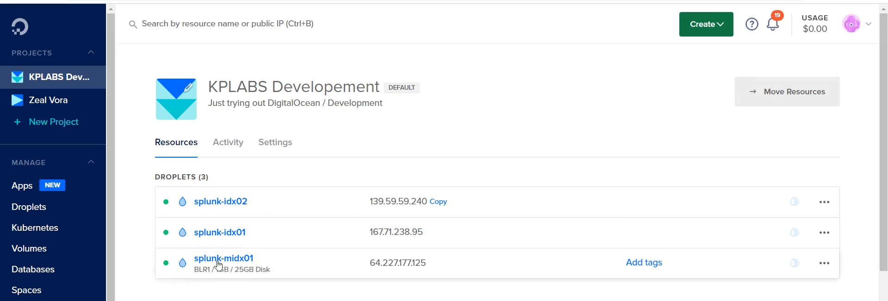

**Infrastructure Plan Summary**

You have clearly outlined the necessary infrastructure for a foundational indexer cluster, focusing on the minimum required components for testing redundancy:

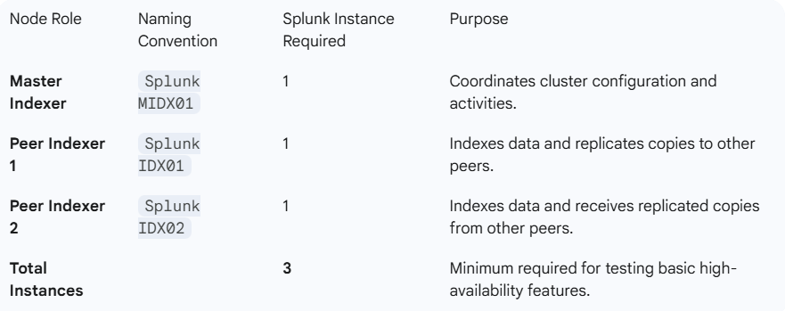

**Actionable Checklist: Infrastructure Readiness**

To ensure you are fully prepared for the next configuration steps, here is a consolidated checklist of the prerequisites:

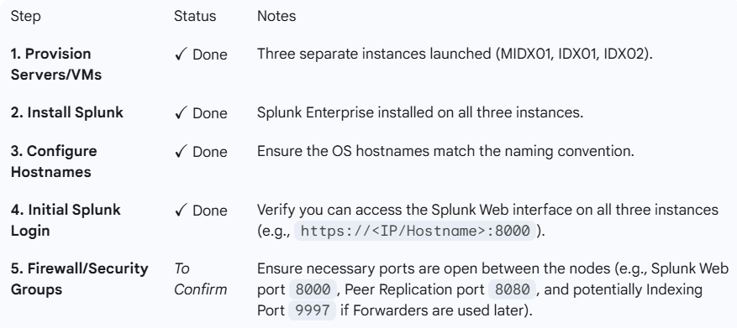

**============================================================================**

1. **Configuring Master Indexer:**

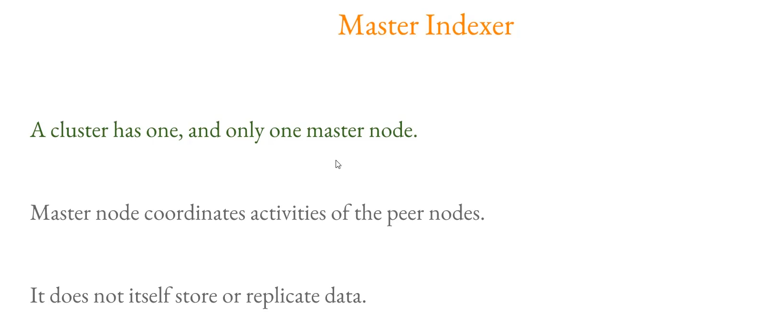

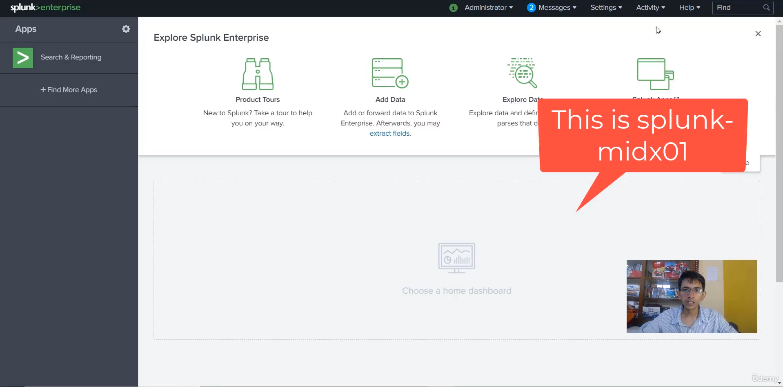

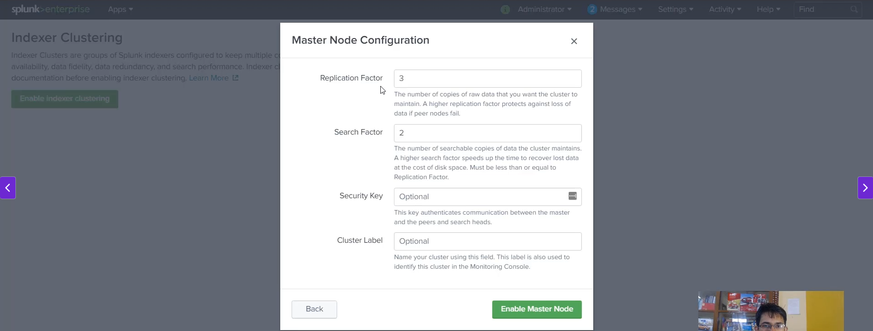

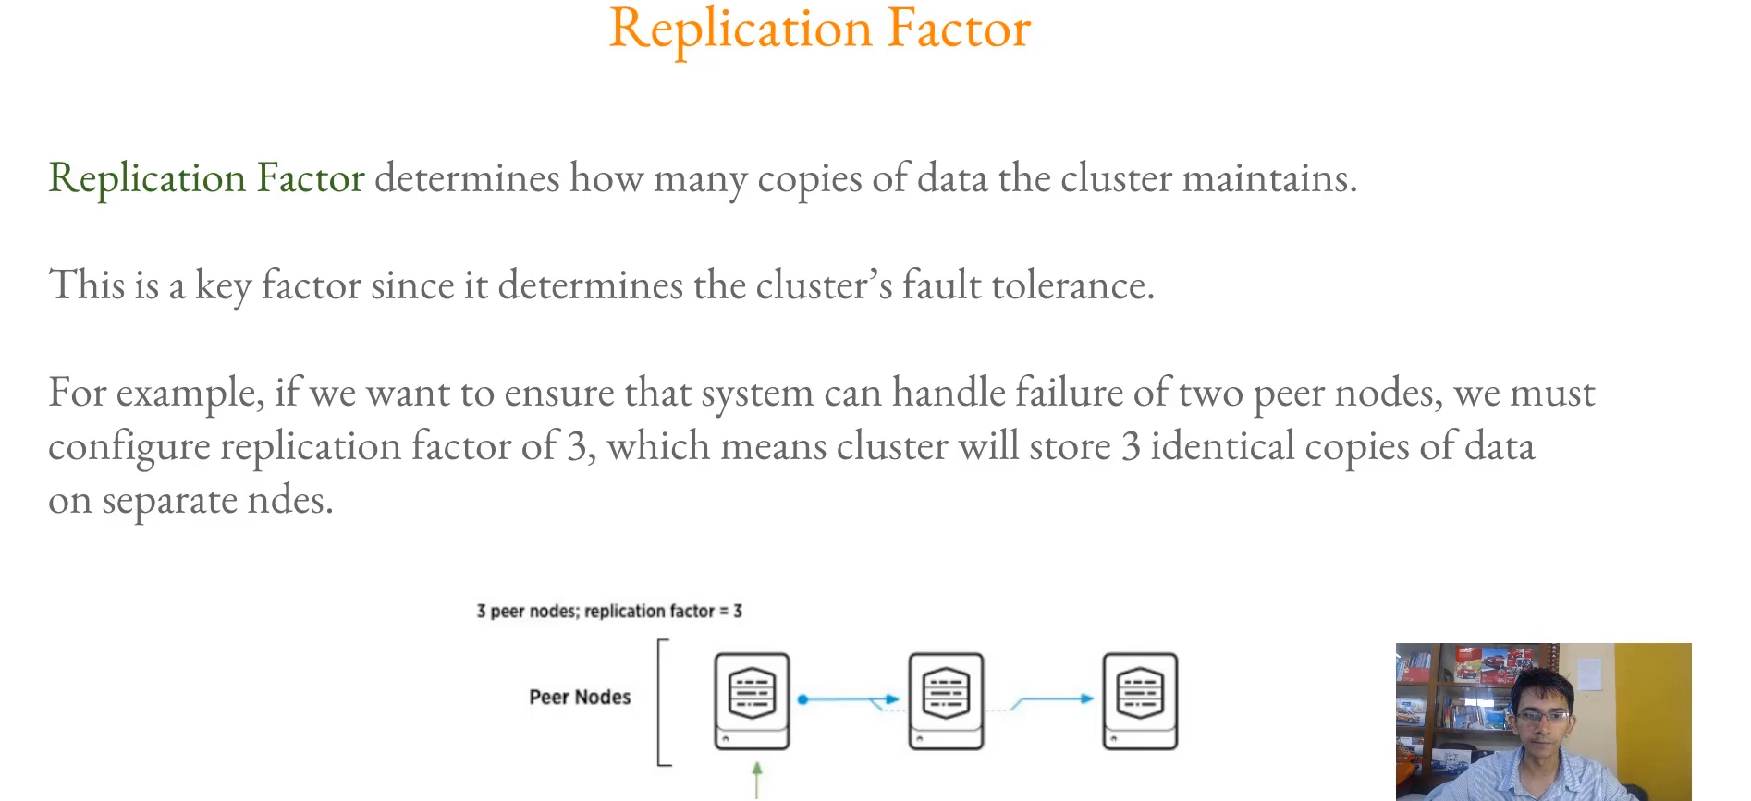

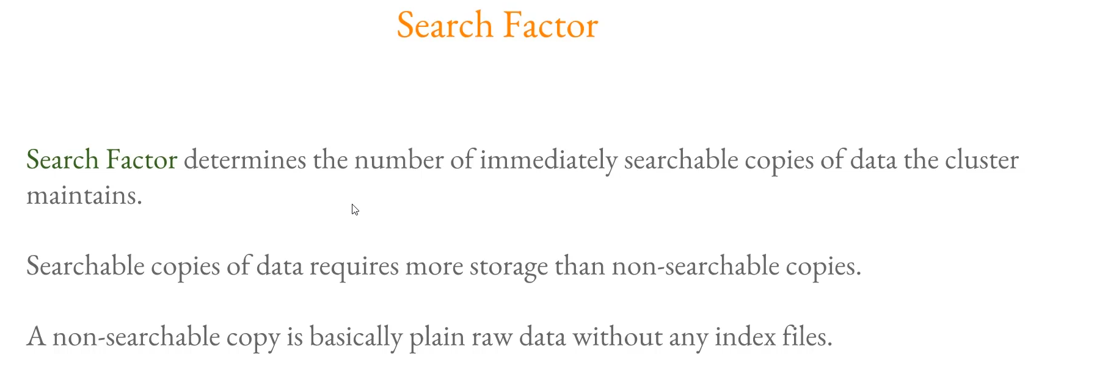

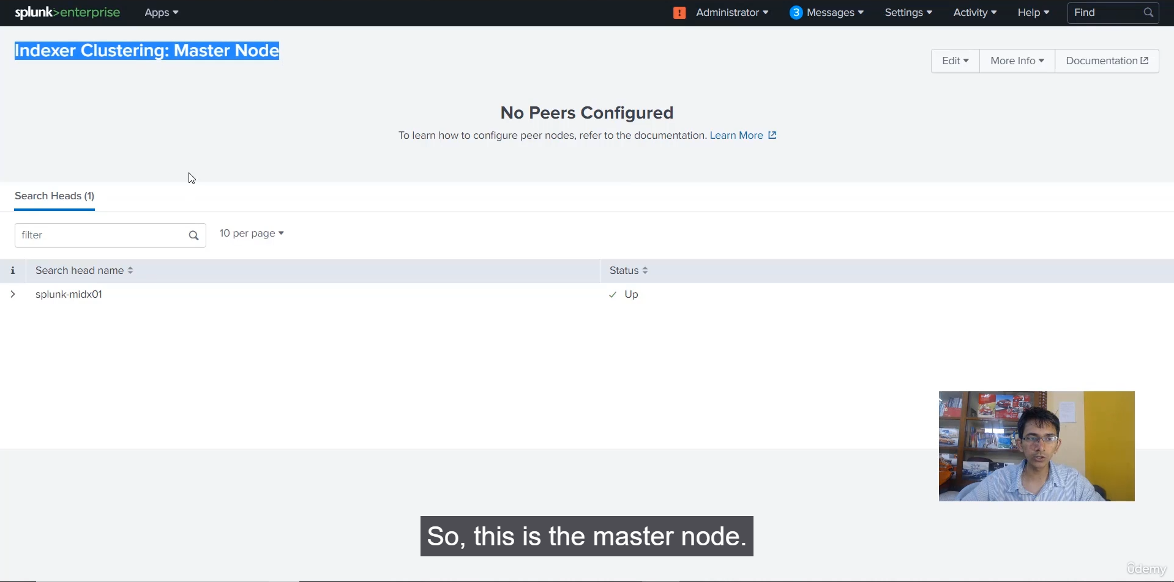

**Master Node Configuration Summary**

You have successfully configured the first component of your indexer cluster. Here is a summary of the configuration steps and key settings:

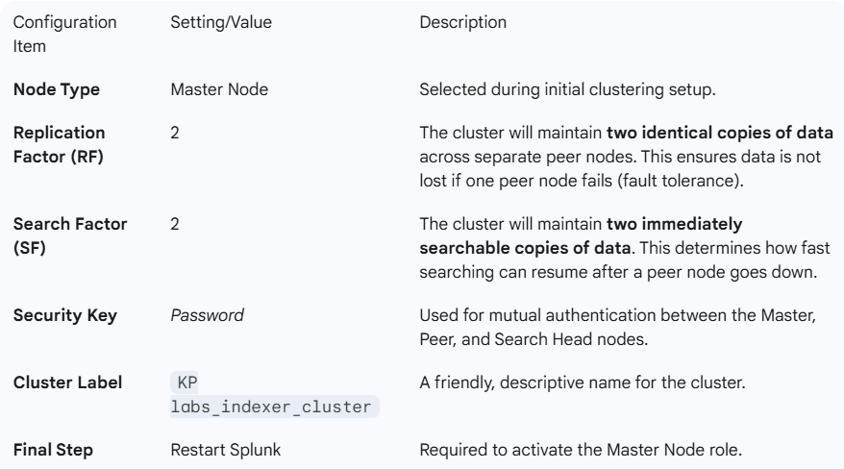

**Understanding Replication Factor vs. Search Factor**

You highlighted the key difference between the two critical factors:

* **Replication Factor (RF):** Deals with **data fidelity/storage**. It is the total number of copies (searchable and non-searchable) maintained. **Formula for Fault Tolerance: RF = Number of nodes that can fail + 1.**
* **Search Factor (SF):** Deals with **data searchability/availability**. It is the number of copies that are immediately searchable (contain both raw data and index files). Maintaining a lower SF than RF can save disk space, as non-searchable copies only contain raw data.

**============================================================================**

1. **Configuring Peer Indexer:**

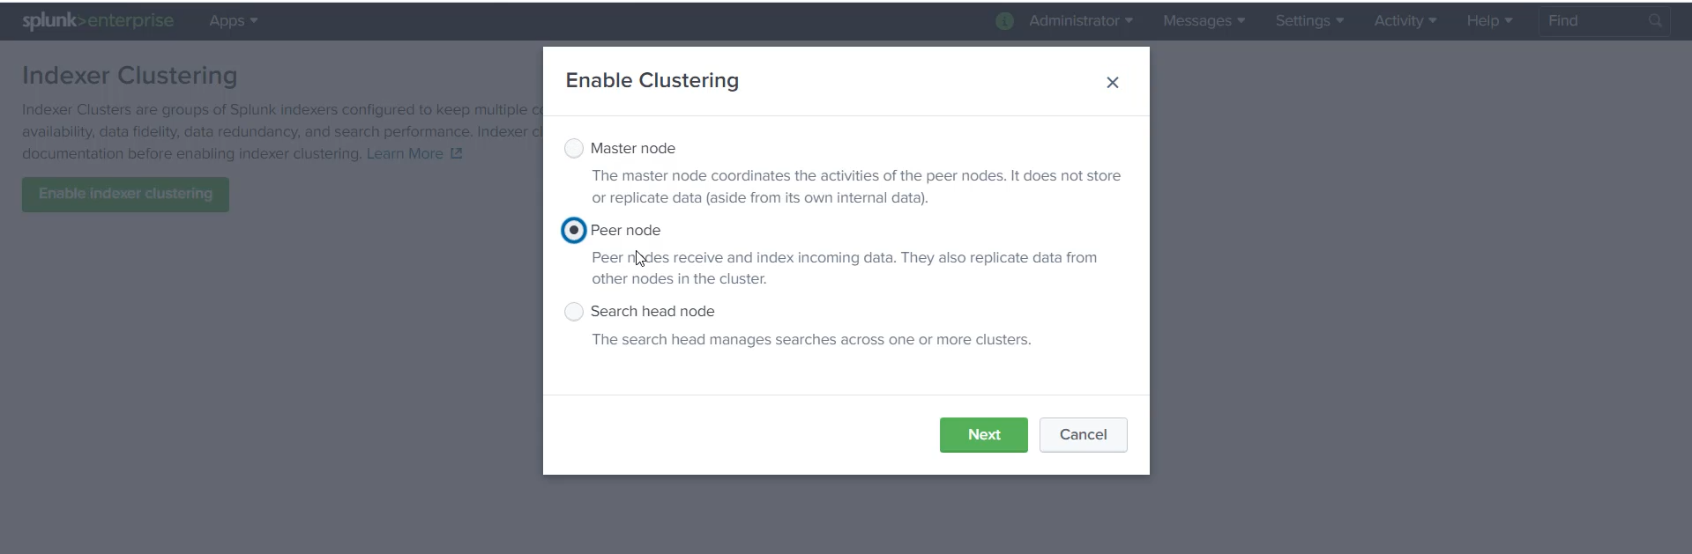

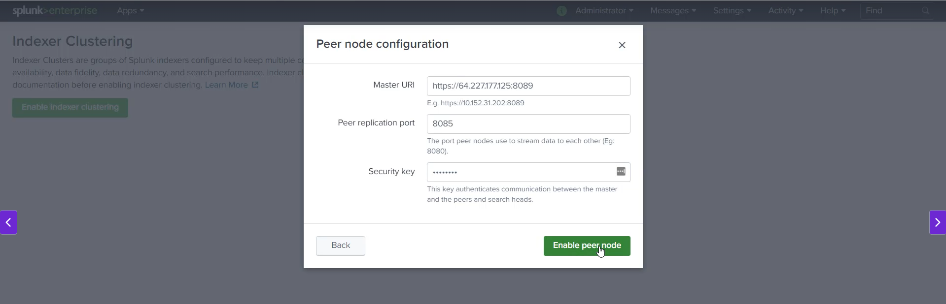

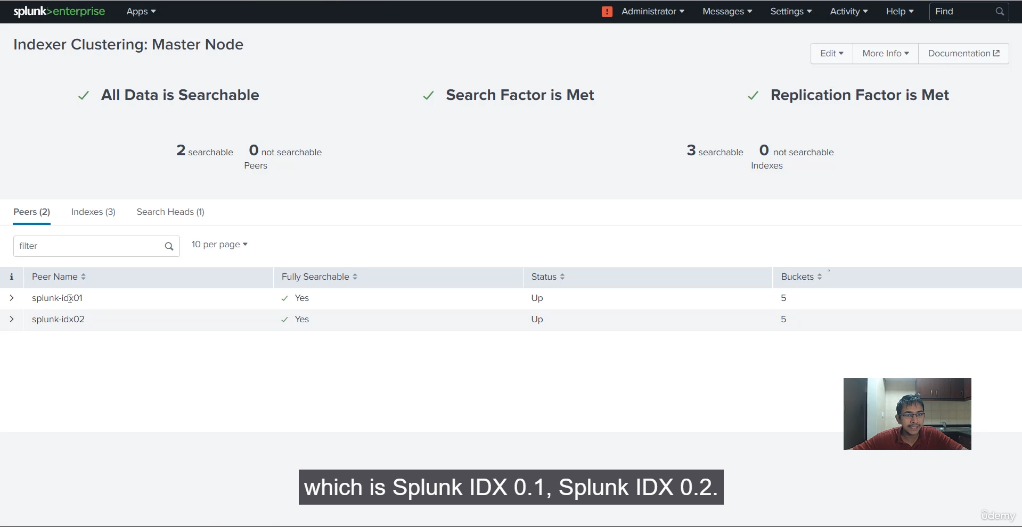

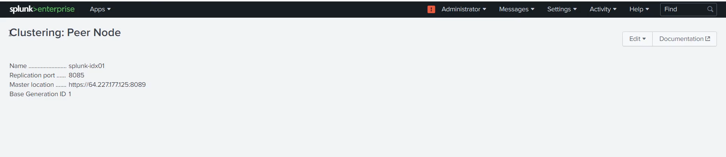

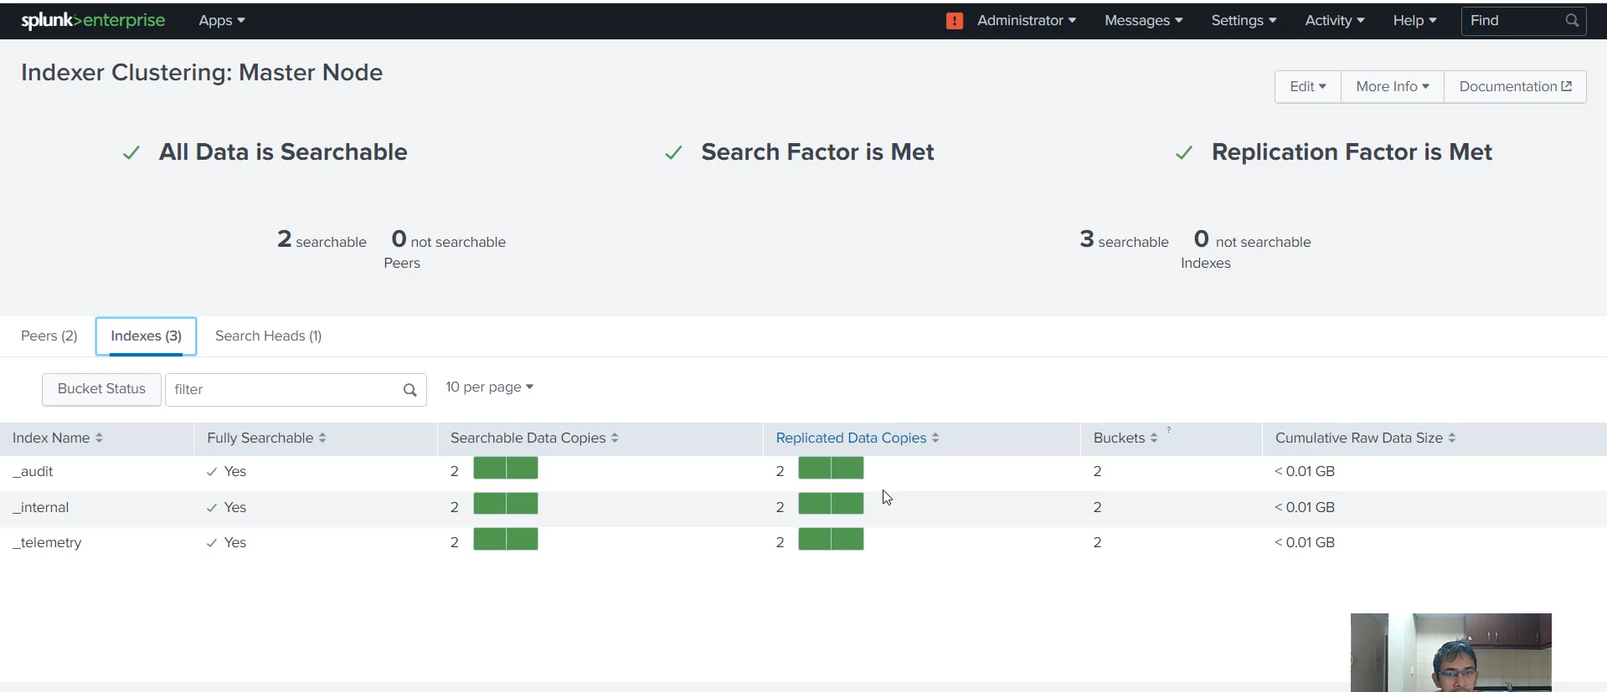

**Peer Node Configuration Summary**

You successfully executed the configuration on both Splunk IDX01 and Splunk IDX02. The key parameters used were:

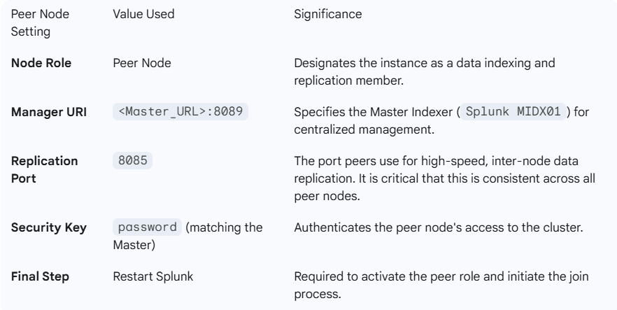

**Cluster Status Verification**

The most important step was verifying the outcome on the Master Indexer's dashboard:

* **Master Indexer Dashboard:** Now shows both Splunk IDX01 and Splunk IDX02 listed under **Peers**.
* **Search and Replication Factors:** The Master dashboard confirms that the Search Factor (SF=2) and Replication Factor (RF=2) are **Matched** across the cluster.
* **Peer Node Dashboard:** Each peer now displays its cluster status and identifies its role as a Peer Node.

This confirmed state means the cluster is healthy and ready to enforce the data redundancy rules (SF=2, RF=2) you defined.

**============================================================================**

1. **Testing Replication Capabilities:**

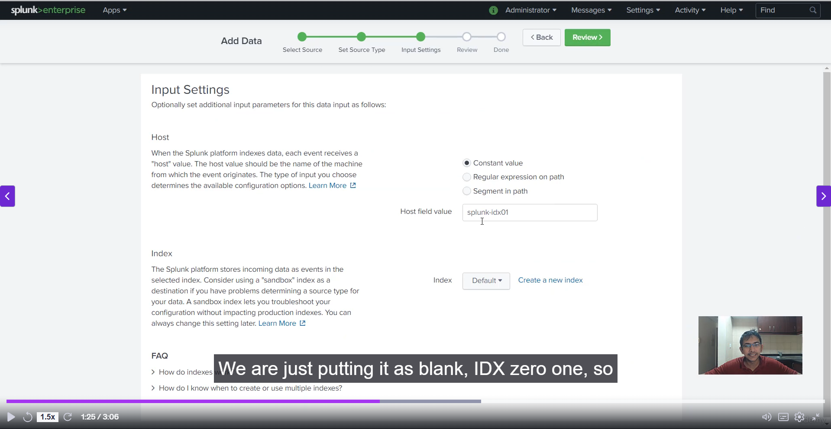

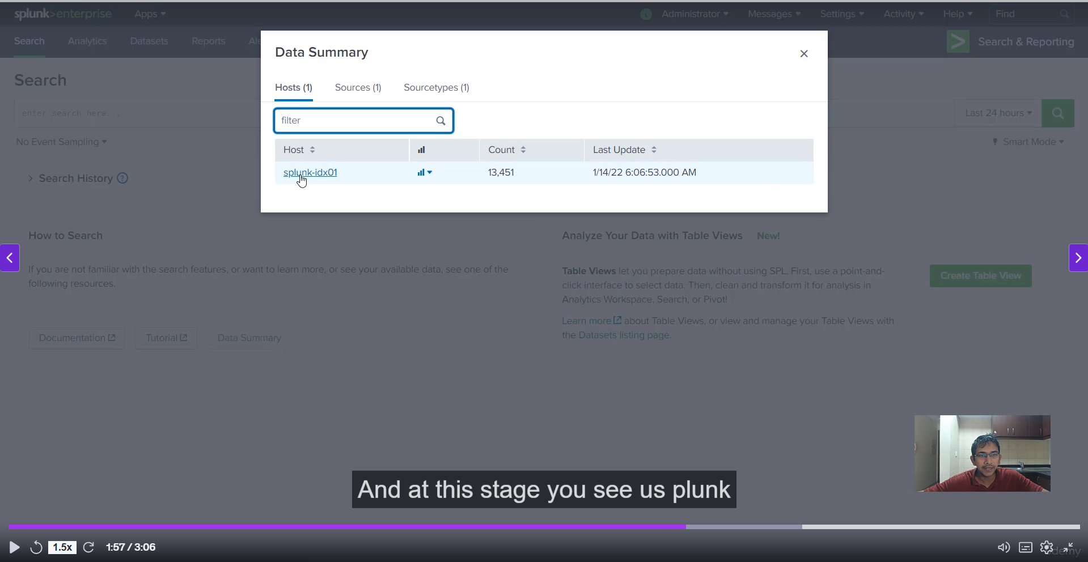

**Replication Test Summary**

Here's a breakdown of the steps and the key result:

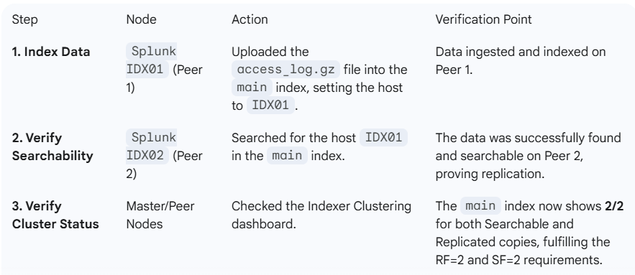

This result confirms that the replication port (8085) and the security key are correctly configured, allowing the peers to stream data copies to each other.

**📊 Cluster Health Indication**

The most important takeaway from this test is the status of your indexes on the cluster dashboard:

* **main Index Status:** **2/2 Searchable / 2/2 Replicated**

This indicates that for every bucket of data added to the main index:

1. **Two** copies are maintained (Replication Factor = 2).
2. **Two** of those copies are immediately searchable (Search Factor = 2).

This sets the stage perfectly for your next topic: **Failure Testing**.

**============================================================================**

1. **Testing Failover Capabilities:**

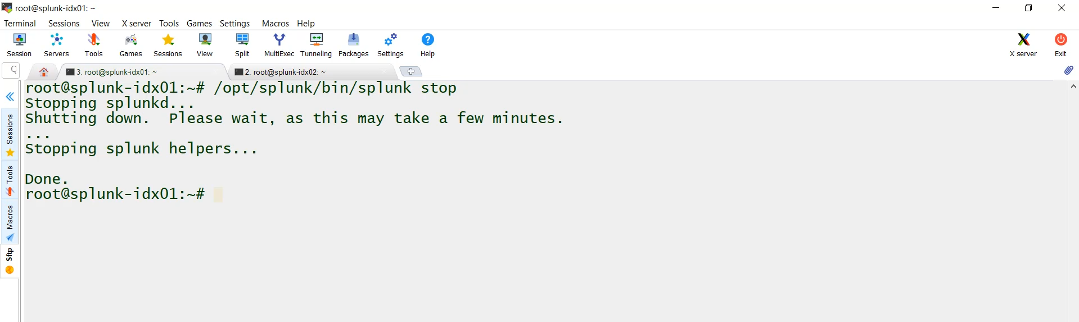

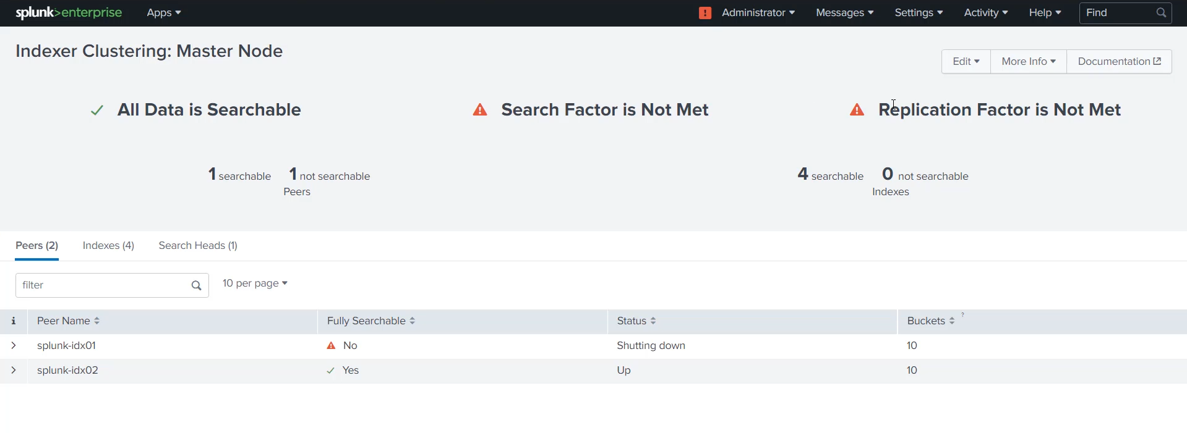

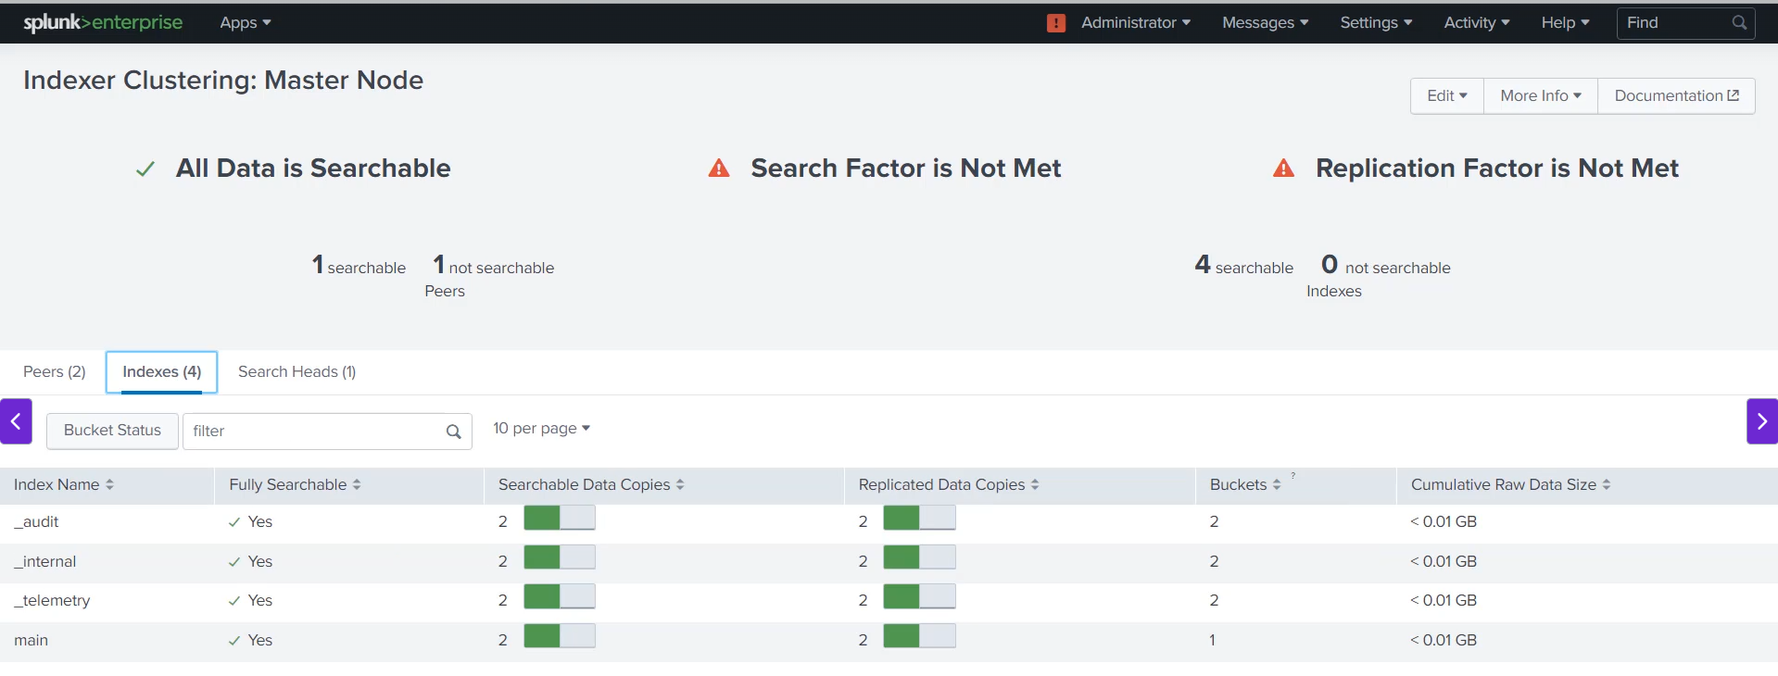

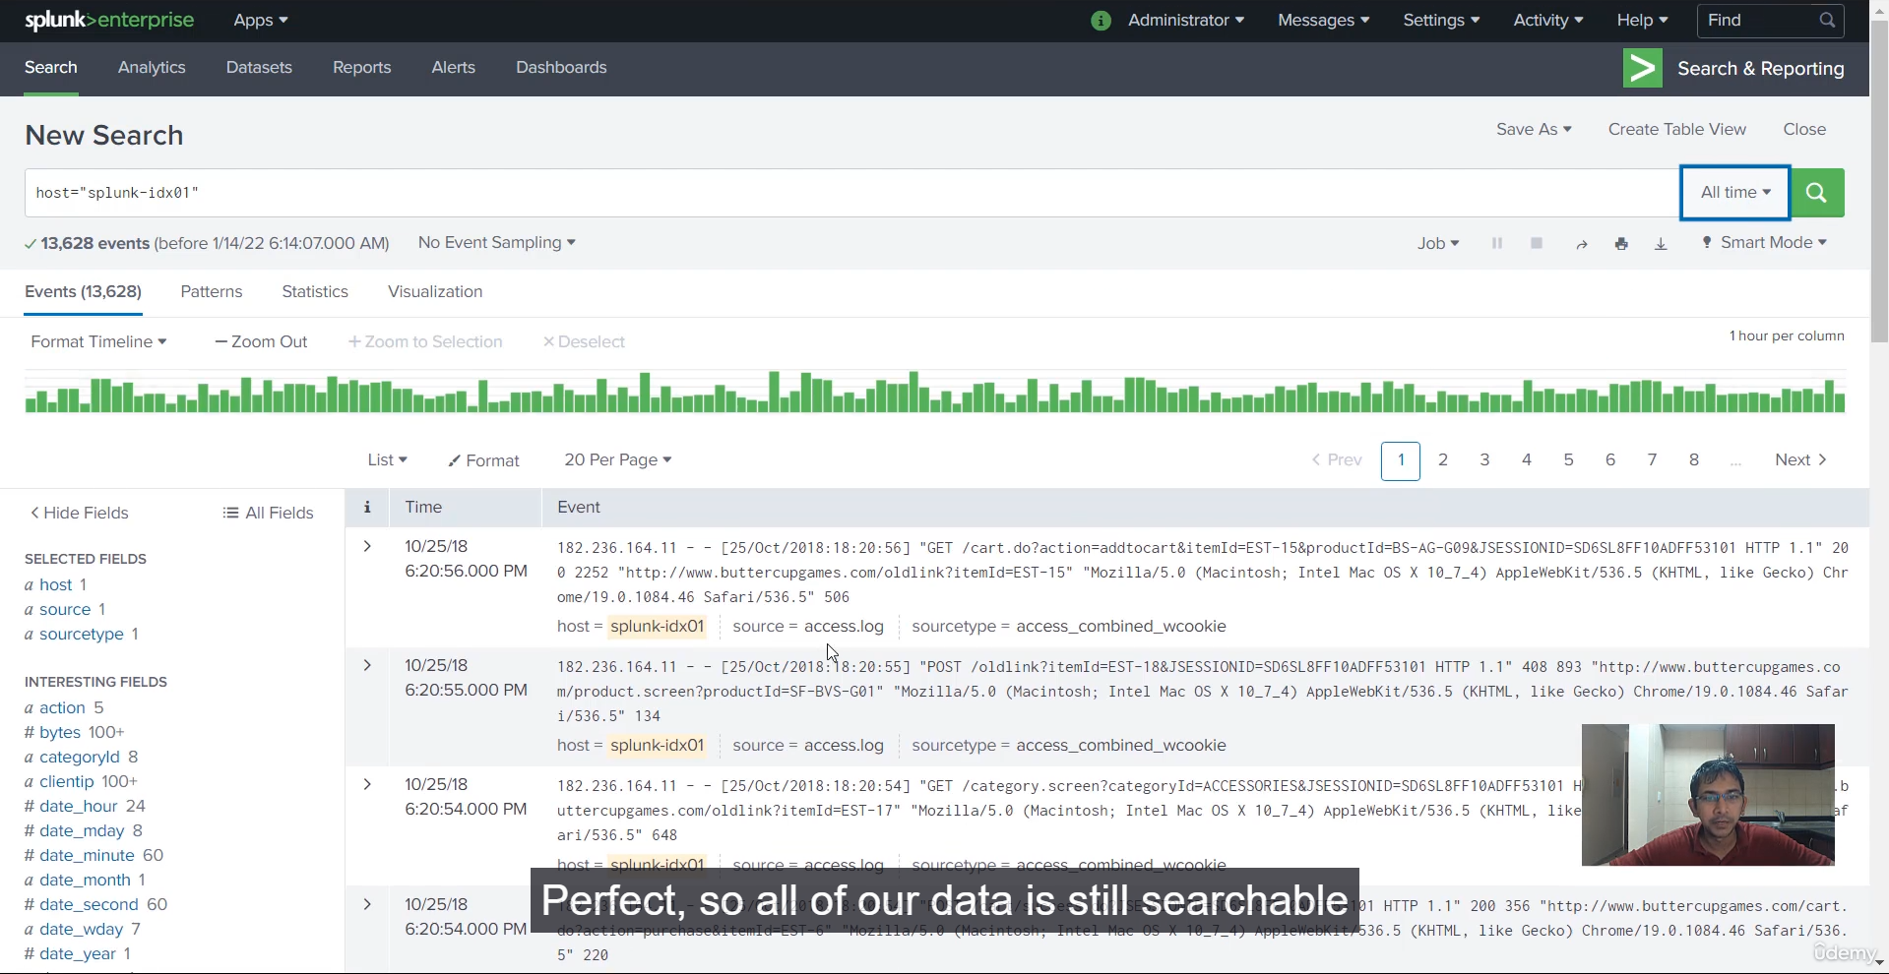

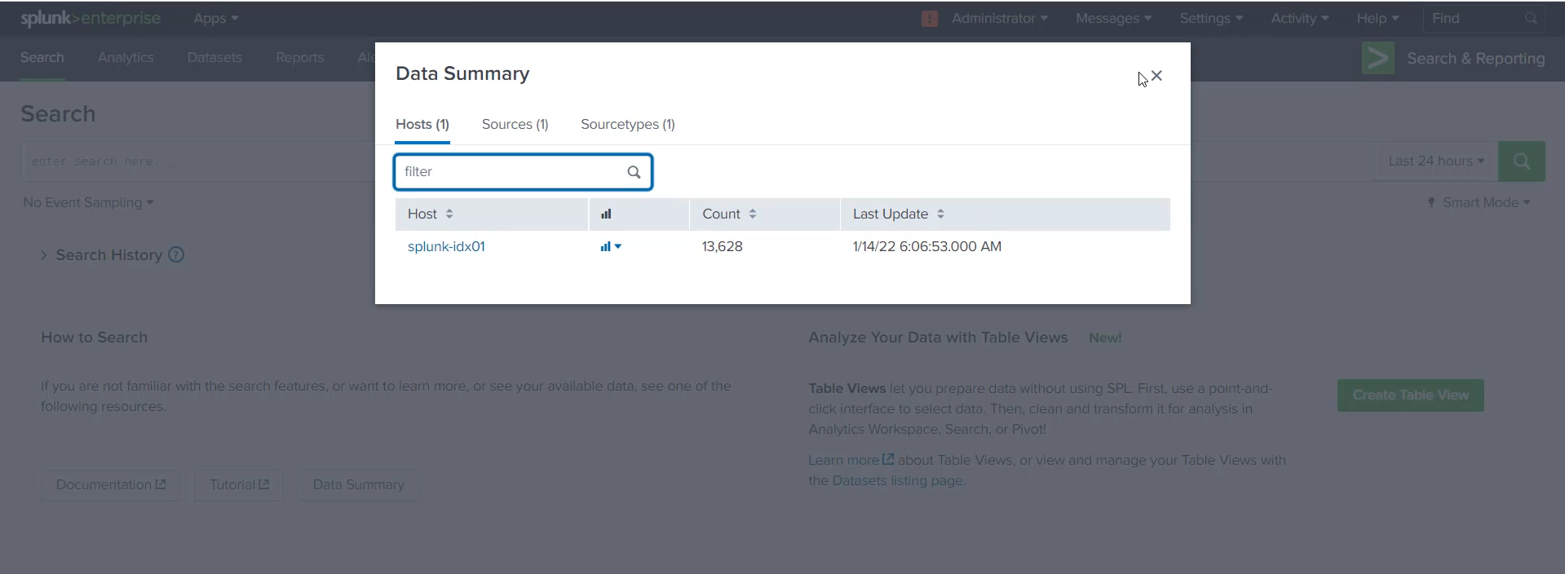

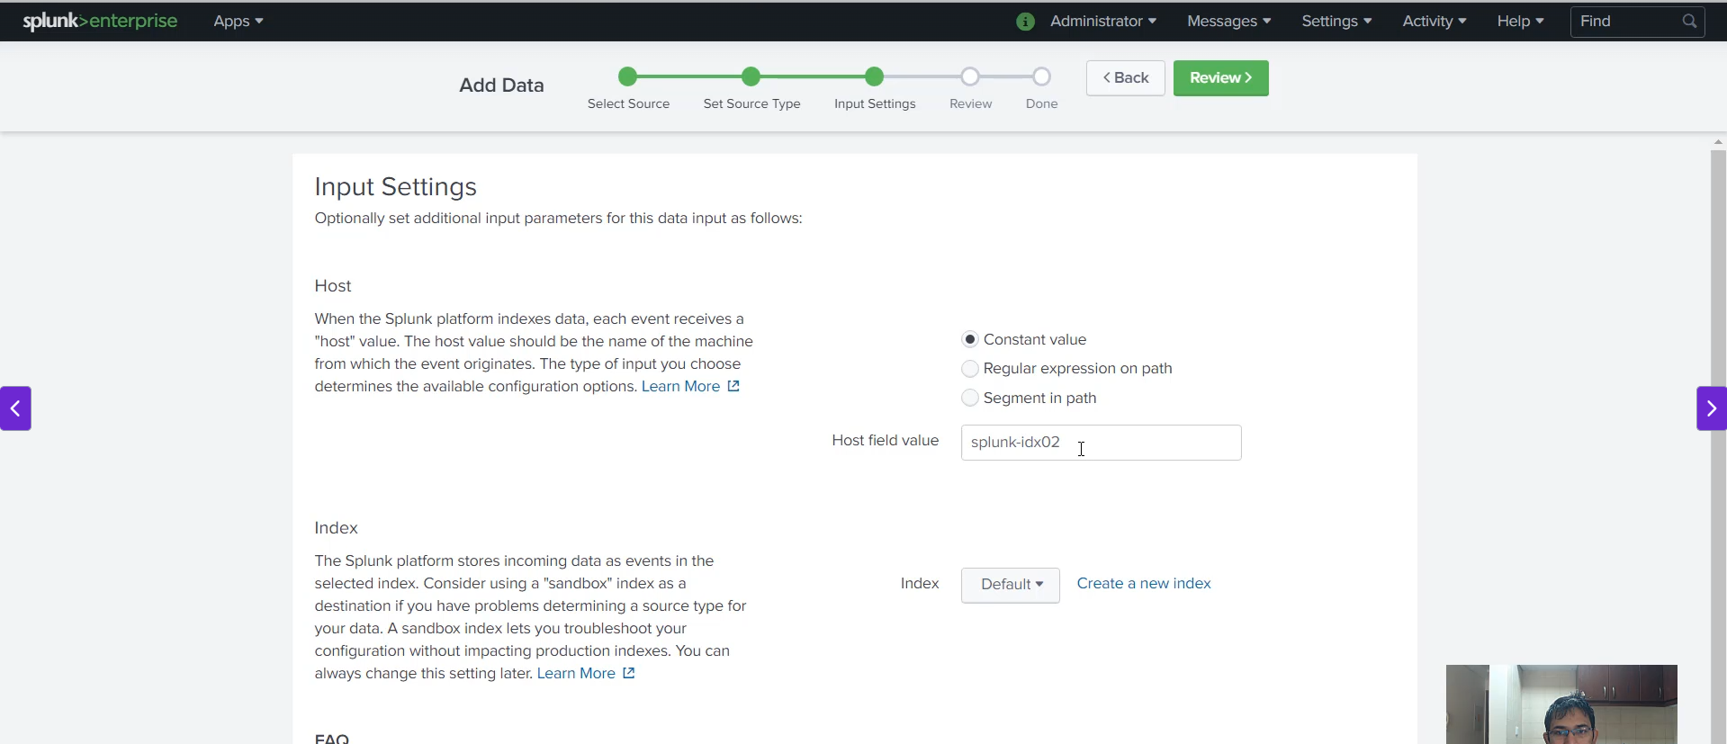

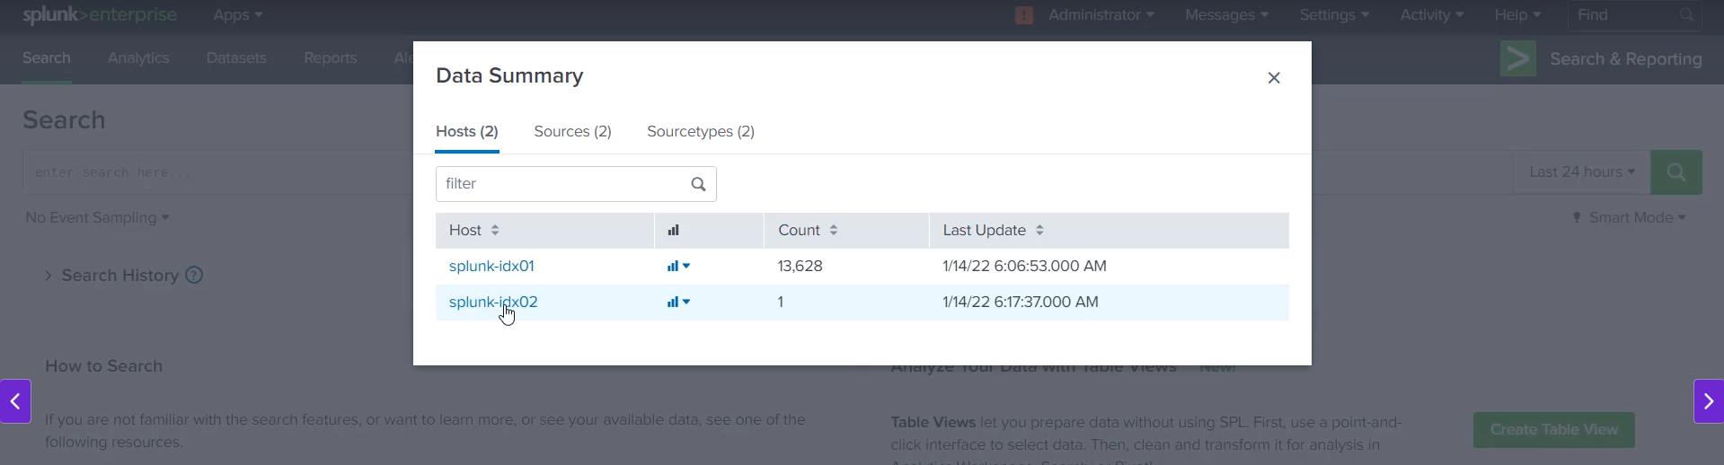

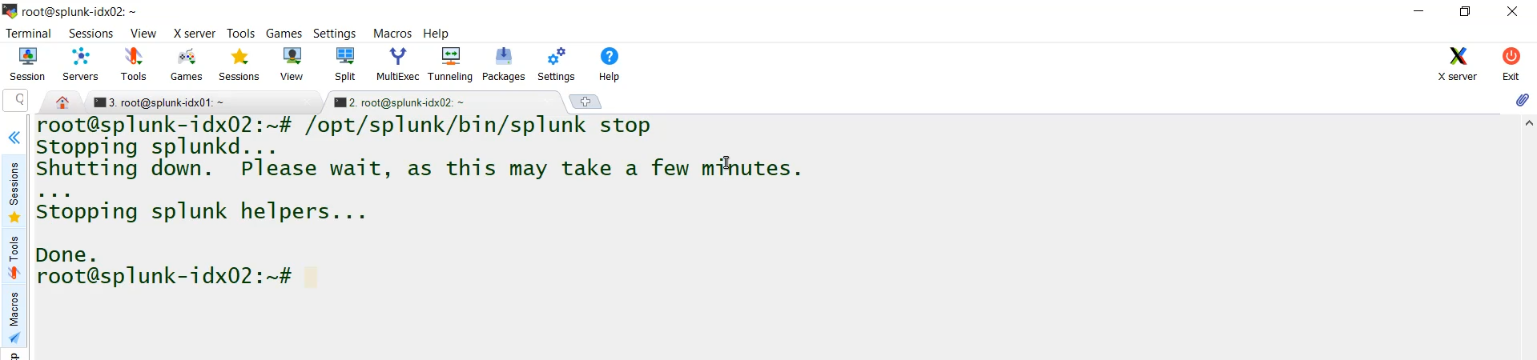

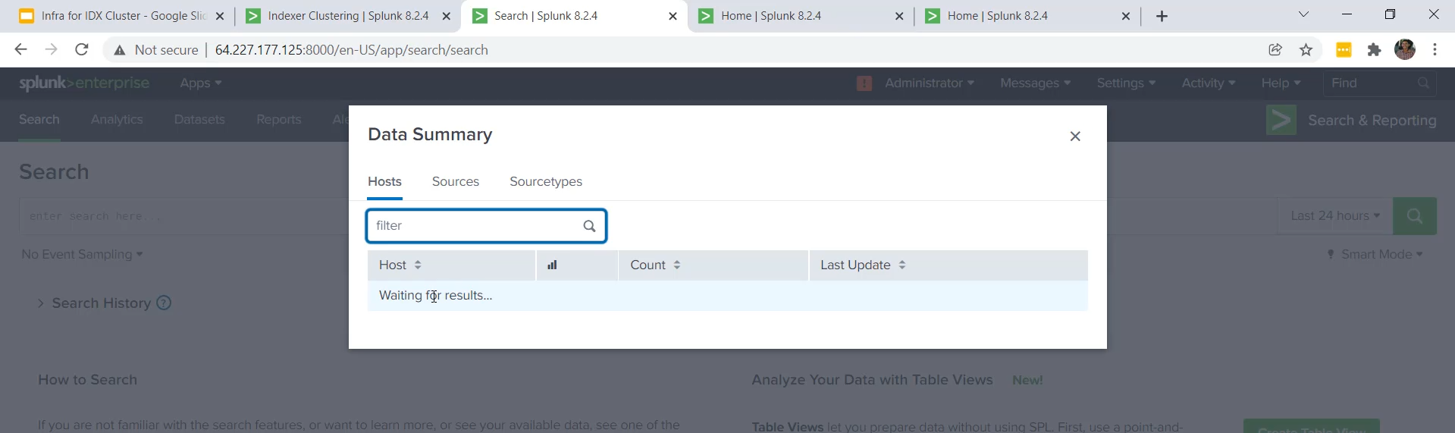

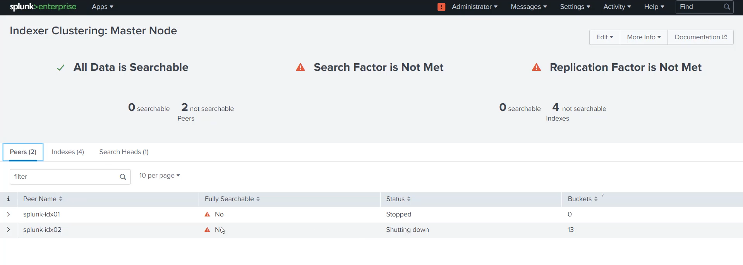

**Splunk Indexer Cluster Failover and Replication Summary**

The video demonstrated the failover and data replication capabilities of a Splunk Indexer Cluster using a configuration with two peer nodes (IDX01 and IDX02) and a Master Indexer (MIDX01) acting as the Search Head.

**1. Testing Data Replication and Search Failover (One Node Down)**

* **Initial State:** Access log data was available (replicated) on both Peer Node 1 (IDX01) and Peer Node 2 (IDX02).
* **Action:** The Splunk instance on **Peer Node 1 (IDX01) was intentionally stopped.**
* **Master Indexer Status:**
  + The Master Indexer (MIDX01) immediately showed alerts: **"Search Factor is not met"** and **"Replication Factor is not met,"** as only one of the two expected nodes was available.
  + It also showed that Splunk IDX01 was "not fully searchable" and "shutting down."
* **Verification:** The data was **still fully searchable** from Peer Node 2 (and the Search Head MIDX01), confirming that **data replication** and **search failover** are working. The cluster remained operational.

**2. Role of the Search Head (MIDX01)**

* The instructor highlighted that in a production environment, users should **ideally perform searches from a dedicated Search Head** (in this demo, the Master Indexer MIDX01 was temporarily serving this role).
* The Search Head is the central point for raising queries and accessing data across all peer nodes in the cluster.

**3. Testing Total Cluster Failure (Both Nodes Down)**

* **Pre-Action Data Upload:** New data (MySQL error.txt) was uploaded specifically to **Peer Node 2 (IDX02)** while Peer Node 1 (IDX01) was still down. This created a scenario where the new data existed only on IDX02.
* **Action:** The Splunk instance on **Peer Node 2 (IDX02) was also stopped.**
* **Result:** With both peer indexers down, the Search Head (MIDX01) could **not retrieve any data**.
  + The Data Summary was empty.
  + The Indexer Cluster status showed **"no peers that are fully searchable"** and **zero searchable/replicated copies.** This confirms that the search capability relies entirely on at least one peer indexer being up.

**4. Cluster Recovery and Data Synchronization**

* **Step 1: Bring up Peer Node 1 (IDX01):**
  + The Master Indexer immediately showed **one searchable copy** and **one replicated copy available.**
  + **Crucial Observation:** The initial access log data was immediately available. However, the **new MySQL error log data was missing** because it was uploaded exclusively to IDX02 while IDX01 was down.
* **Step 2: Bring up Peer Node 2 (IDX02):**
  + The Master Indexer showed **IDX02 as fully searchable.**
  + The cluster entered a synchronization state where the **missing data (MySQL error log)** was being **replicated** from IDX02 to IDX01.
* **Final Verification:** After giving the cluster a minute to complete replication, the Master Indexer's Data Summary showed **both the original access log data (from IDX01/replicated) AND the new MySQL error log data (from IDX02/replicated)**, confirming the successful recovery and full data availability across the cluster.

===================================================================================

1. **Configuration Bundles of Master Indexers:**

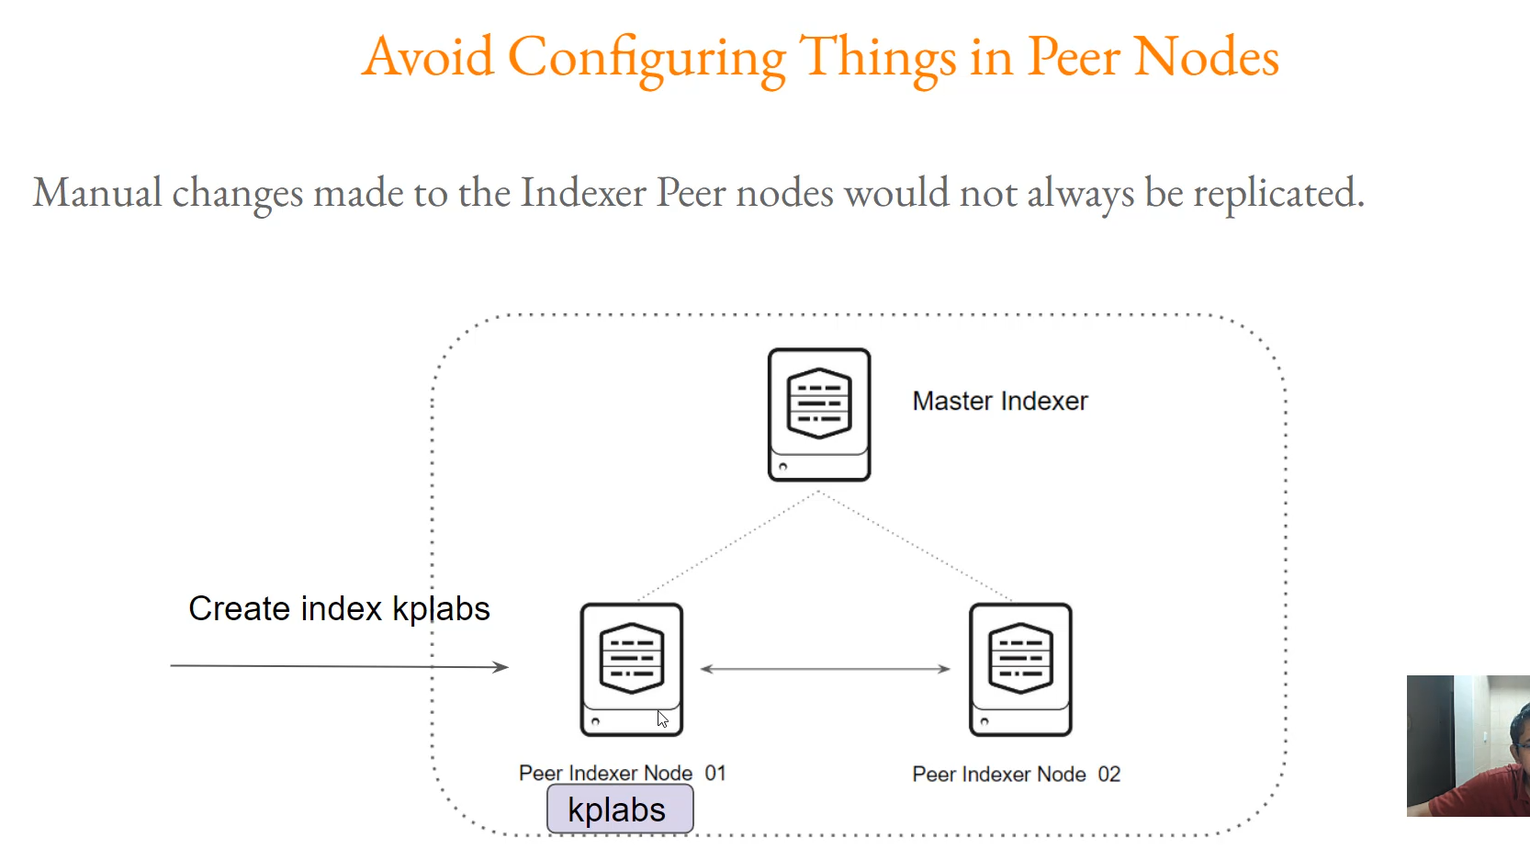

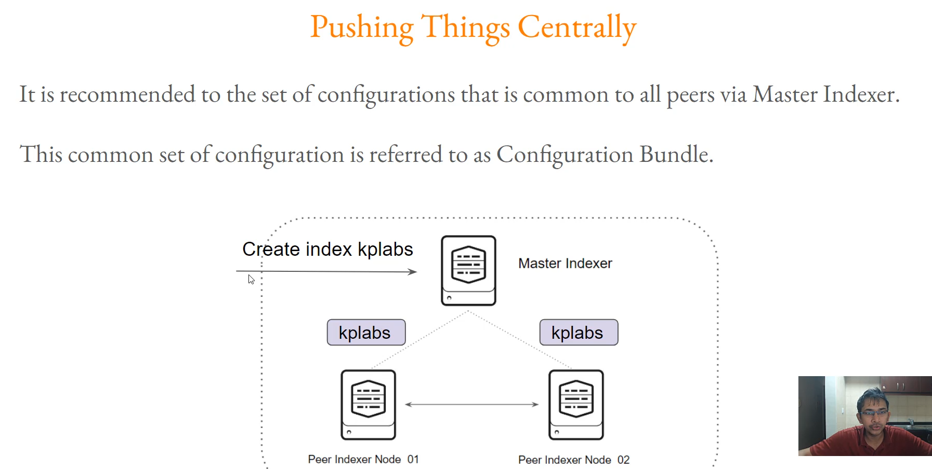

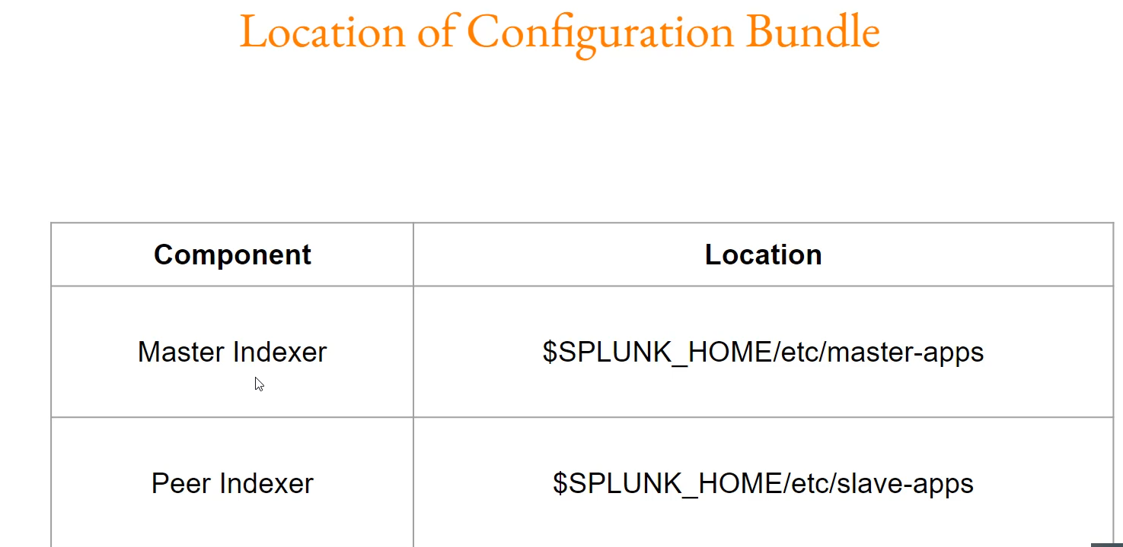

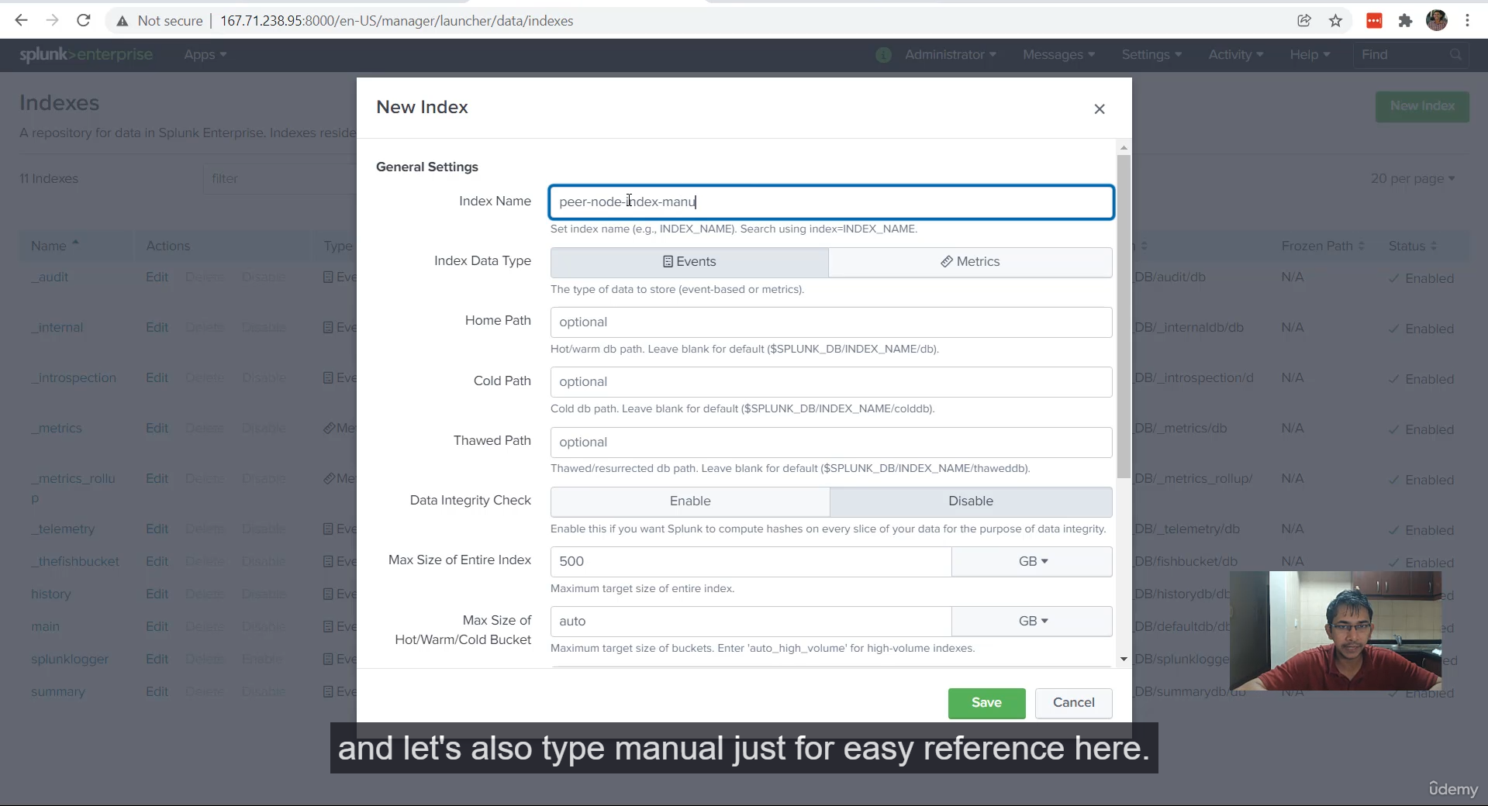

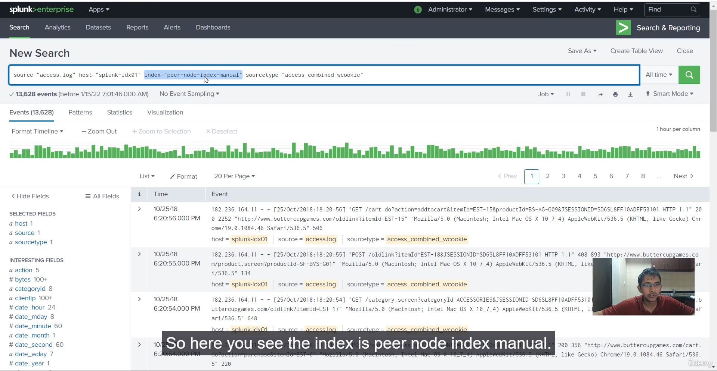

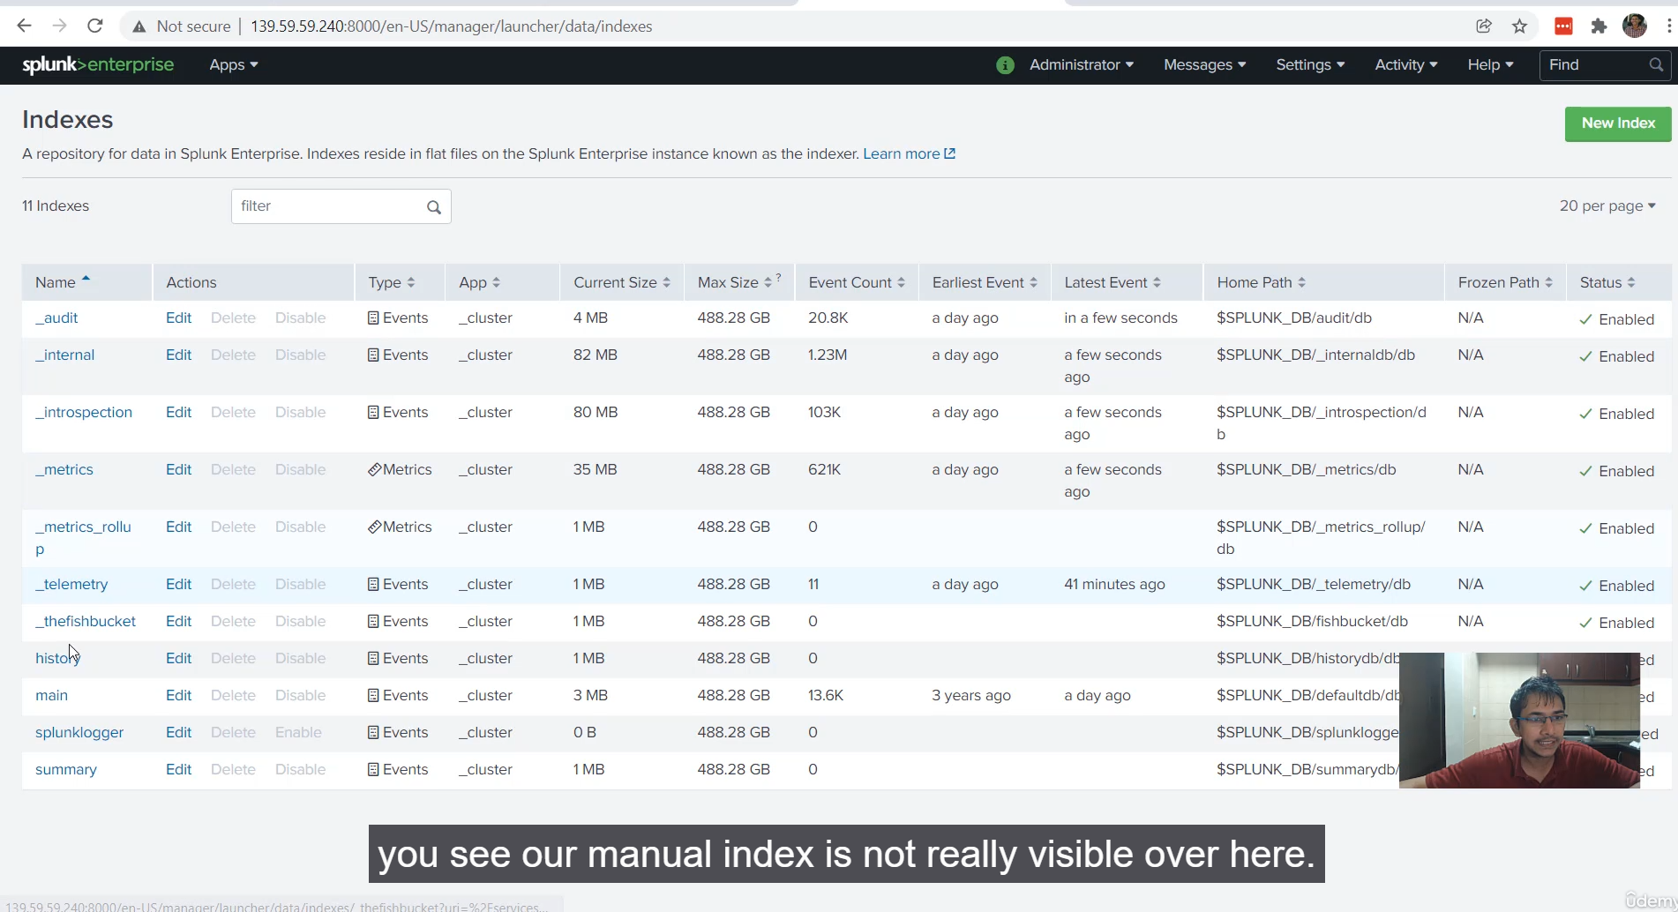

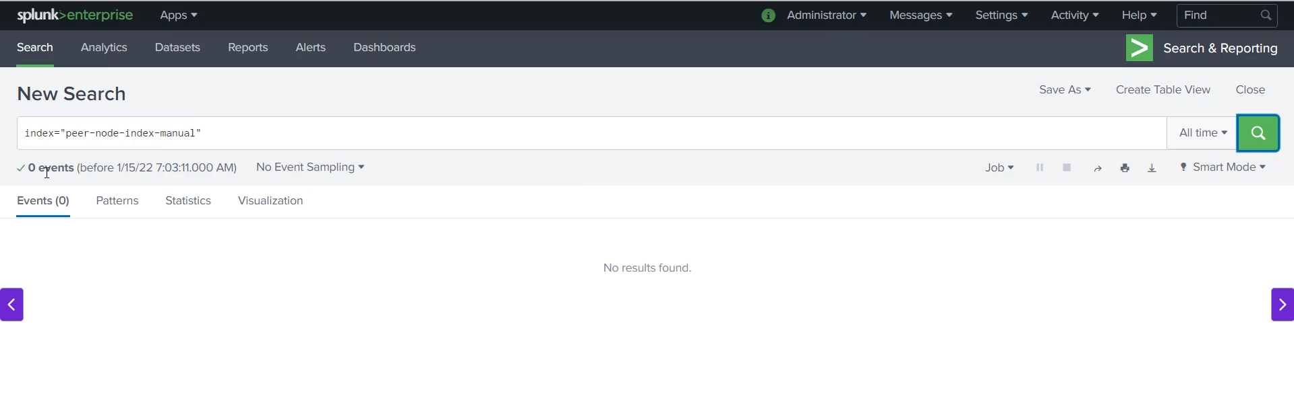

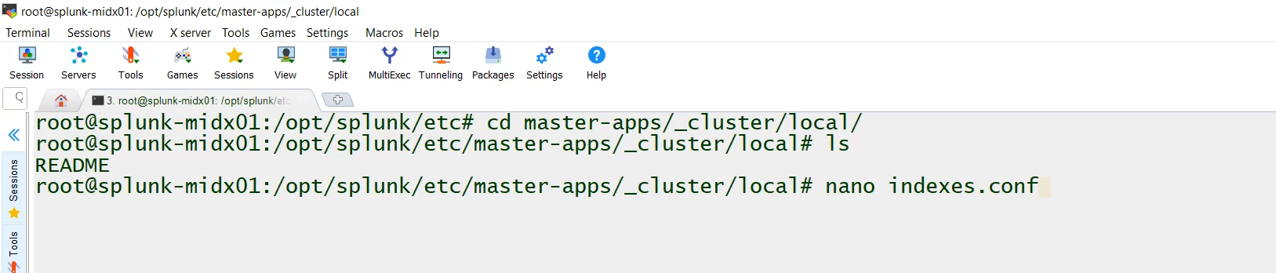

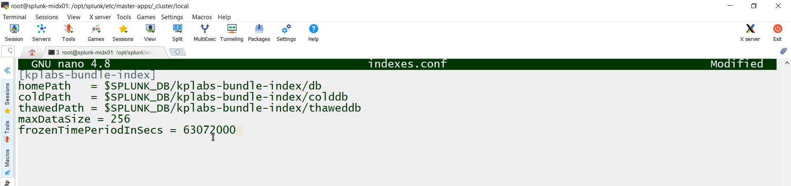

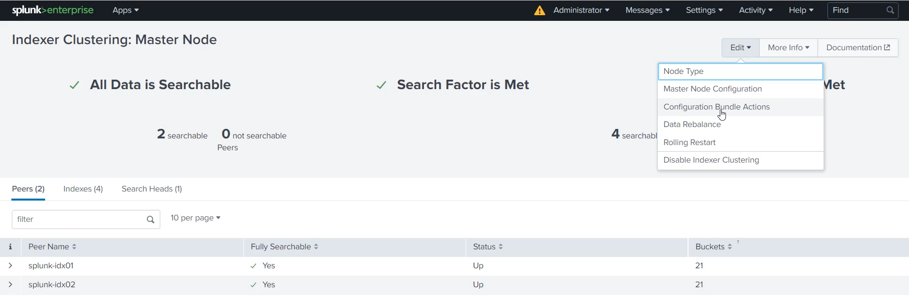

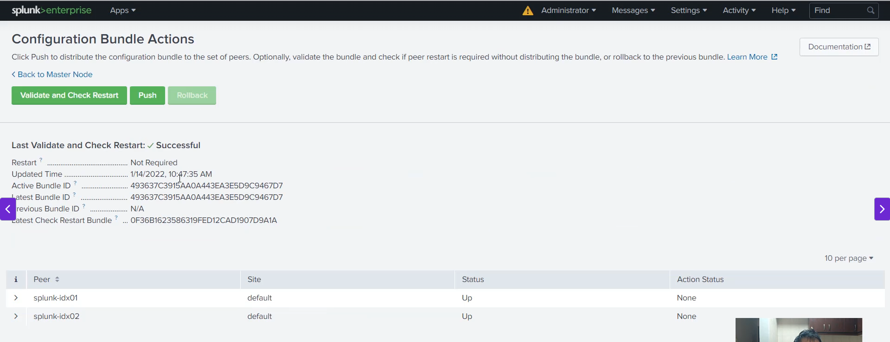

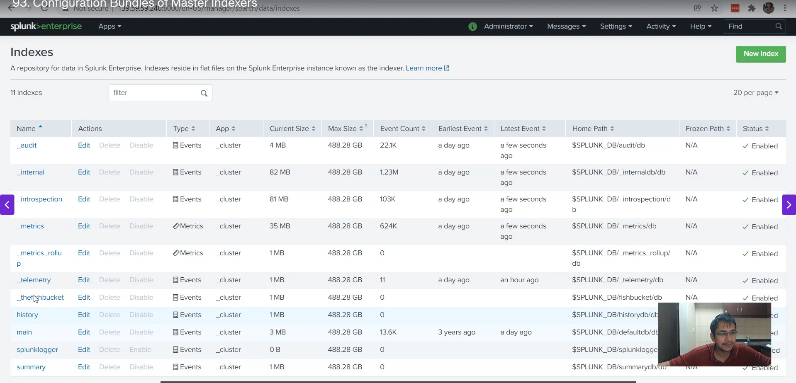

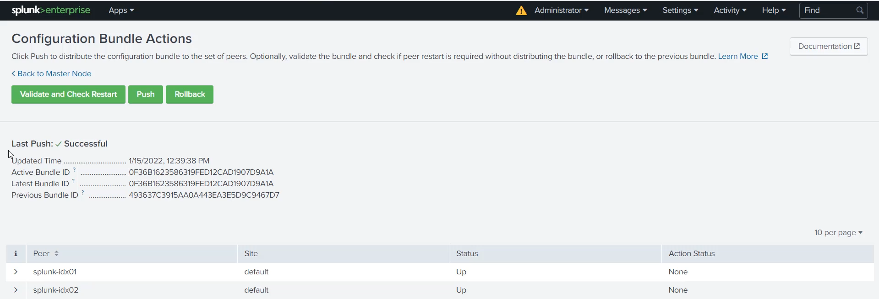

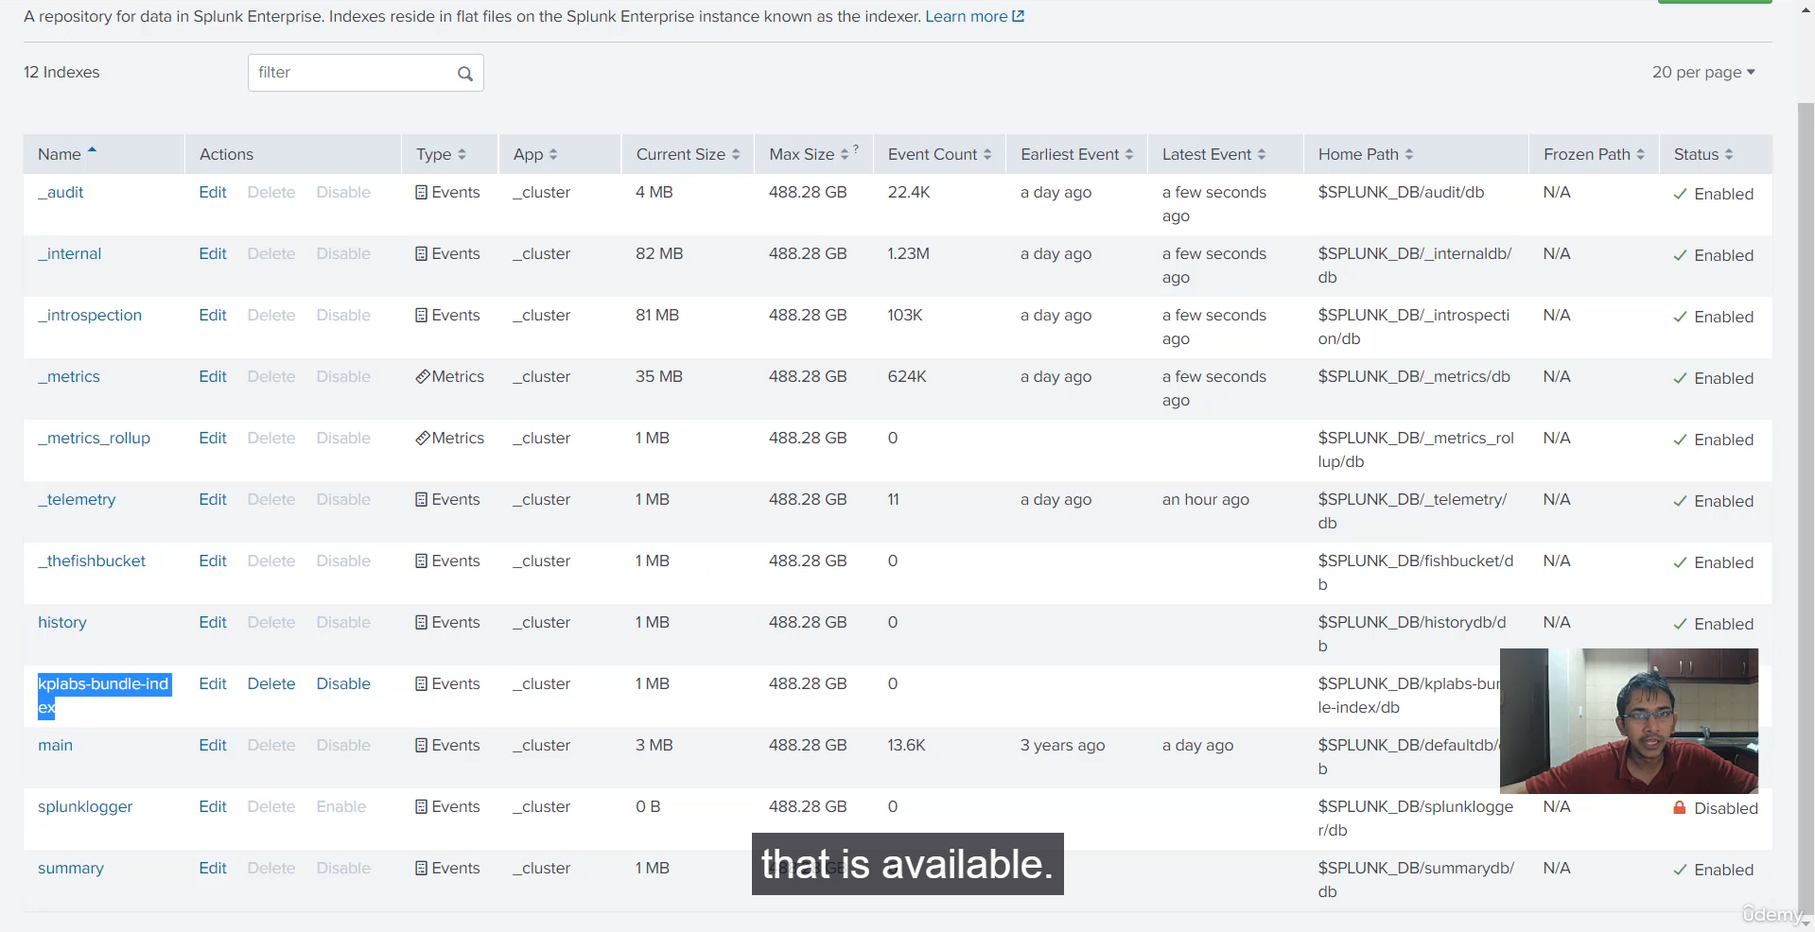

**Splunk Indexer Cluster: Configuration Bundle Summary**

This video explains the critical concept of the **Configuration Bundle** in a Splunk indexer cluster, emphasizing the best practice of making all common peer-level configuration changes through the Master Indexer.

**1. The Problem: Avoiding Manual Peer Changes**

* **The Rule:** **Never make manual configuration changes directly on the peer indexer nodes.**
* **The Risk:** If you create a new configuration (e.g., an index called KP_labs) directly on Peer Node 1 (IDX01), that configuration **will not be automatically replicated** to Peer Node 2 (IDX02) or any other peer nodes.
* **Demonstration:**
  + A manual index (peer_node_index_manual) was created on Peer Node 1, and data was uploaded to it.
  + **Result:** This index and its data were **not visible or searchable** from Peer Node 2, proving that manual peer changes break consistency.

**2. The Solution: Configuration Bundle**

* **Definition:** A common set of configurations (like indexes, source types, or installed apps/add-ons) that are pushed from the Master Indexer to all Peer Indexer nodes simultaneously.
* **The Right Way:** Define the new configuration (e.g., a new index) at the Master Indexer level, and let the Master Indexer push it out to the cluster.

**3. Configuration Bundle Directory Structure**

The Master Indexer uses specific directories to store configurations meant for the cluster:

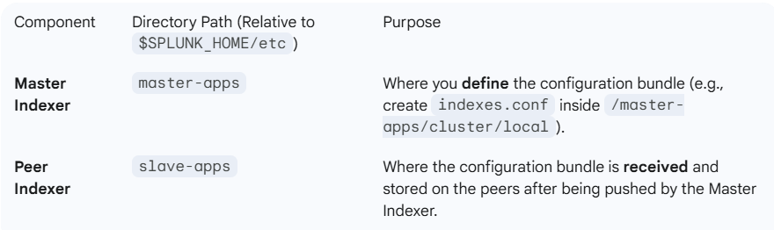

**Note:** $SPLUNK_HOME is a variable used in documentation (e.g., /opt/splunk on Linux) to represent the Splunk installation directory, as it changes based on the operating system.

**4. Practical Steps to Push a Configuration Bundle**

1. **Create the Configuration File:**
   * Navigate to the Master Indexer's bundle location: $SPLUNK_HOME/etc/master-apps/cluster/local/.
   * Create the necessary configuration file (e.g., indexes.conf).
   * The instructor created a stanza for a new index called KP_labs_bundle_index inside this file.
2. **Push the Bundle:**
   * From the Master Indexer's UI, navigate to **Indexer Clustering**.
   * Select **Edit** $\rightarrow$ **Configuration Bundle Actions**.
   * Use the **"Validate and Check Restart"** option first (this step determined no restart was needed for a simple index change).
   * Select **"Push Configuration Bundle."**
3. **Verification:**
   * Immediately check the Peer Indexers (IDX01 and IDX02).
   * **Result:** The new KP_labs_bundle_index was successfully created and visible on **both** peer indexer nodes, confirming the successful deployment.

**5. Rollback Capability**

* The Master Indexer also provides a **"Rollback"** option within the Configuration Bundle Actions.
* The rollback process:
  + The Master Indexer initiates a restart of the affected peer nodes.
  + **Result:** After the rollback, the KP_labs_bundle_index that was just pushed was successfully removed from the peer nodes (demonstrated on Peer 0-1).

**6. Broader Application**

* **The principle applies to all common configurations, not just indexes.**
* Any shared component, such as third-party **applications or add-ons** (like the AWS add-on), must be pushed from the Master Indexer to ensure consistency and proper operation across the entire indexer cluster.

**============================================================================**

1. **Forwarding logs to indexer cluster:**

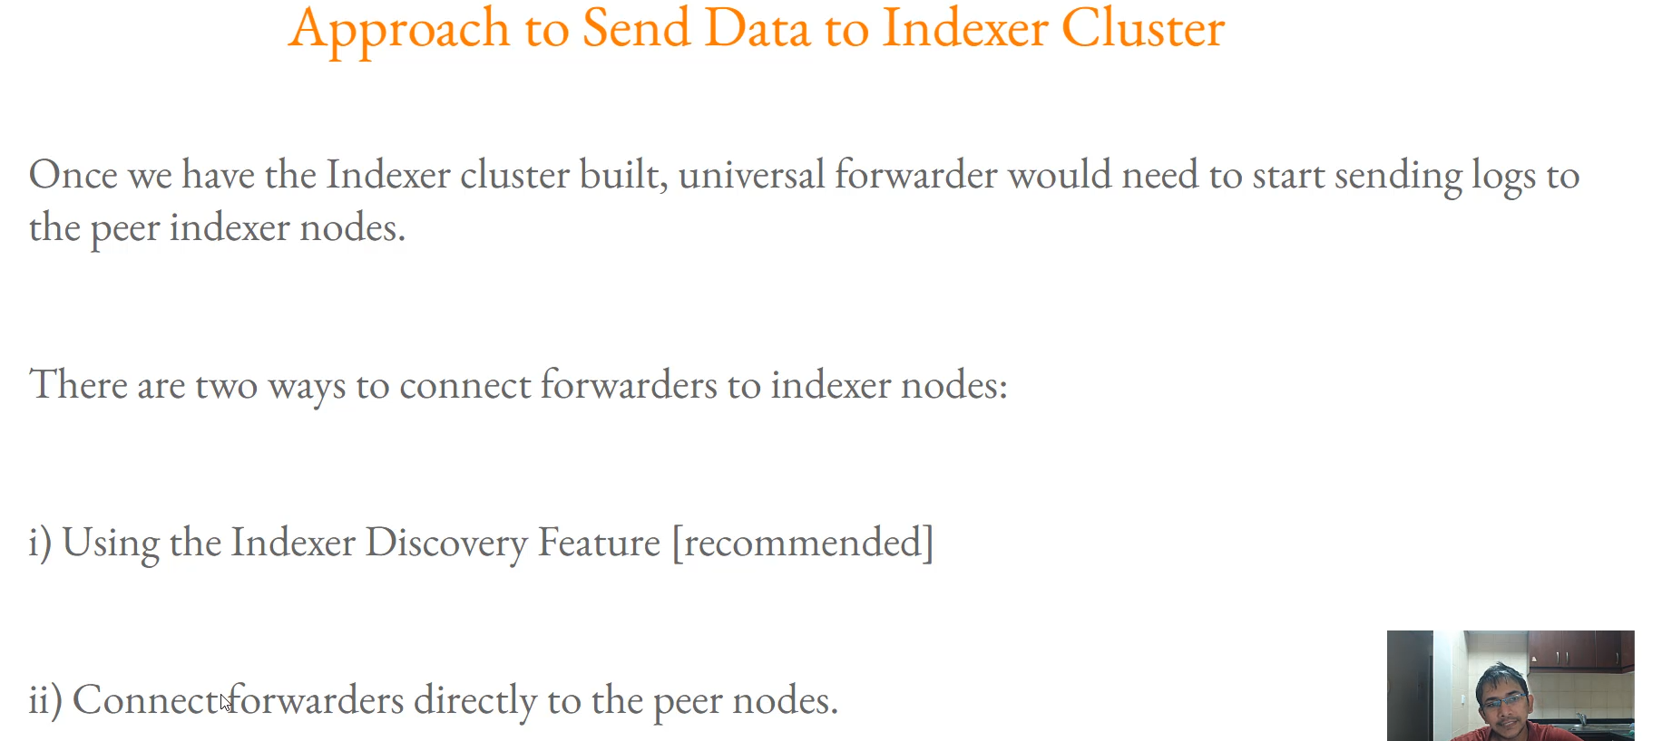

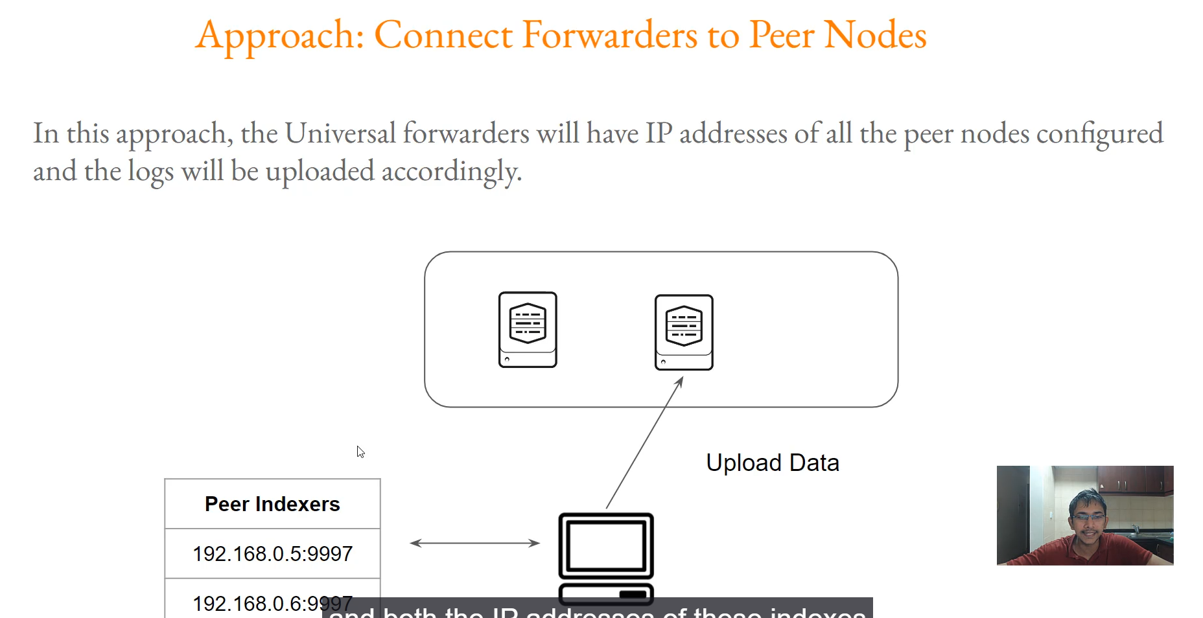

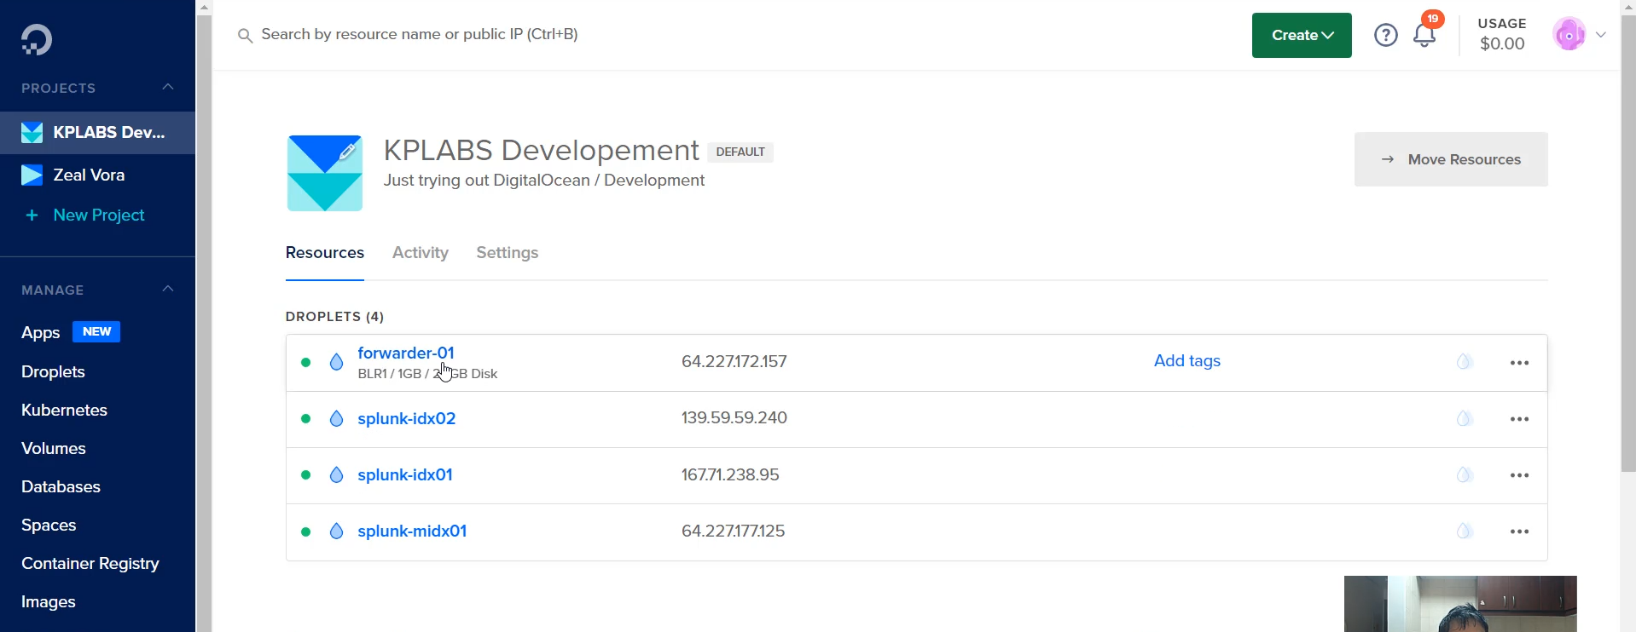

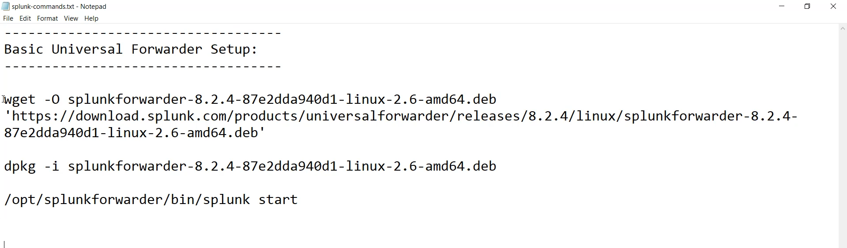

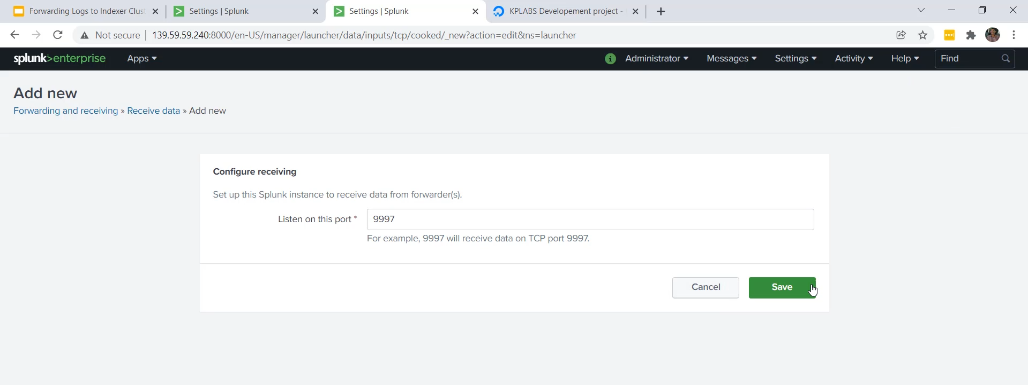

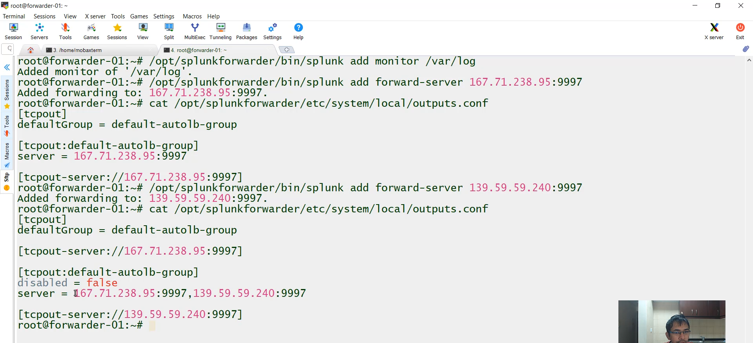

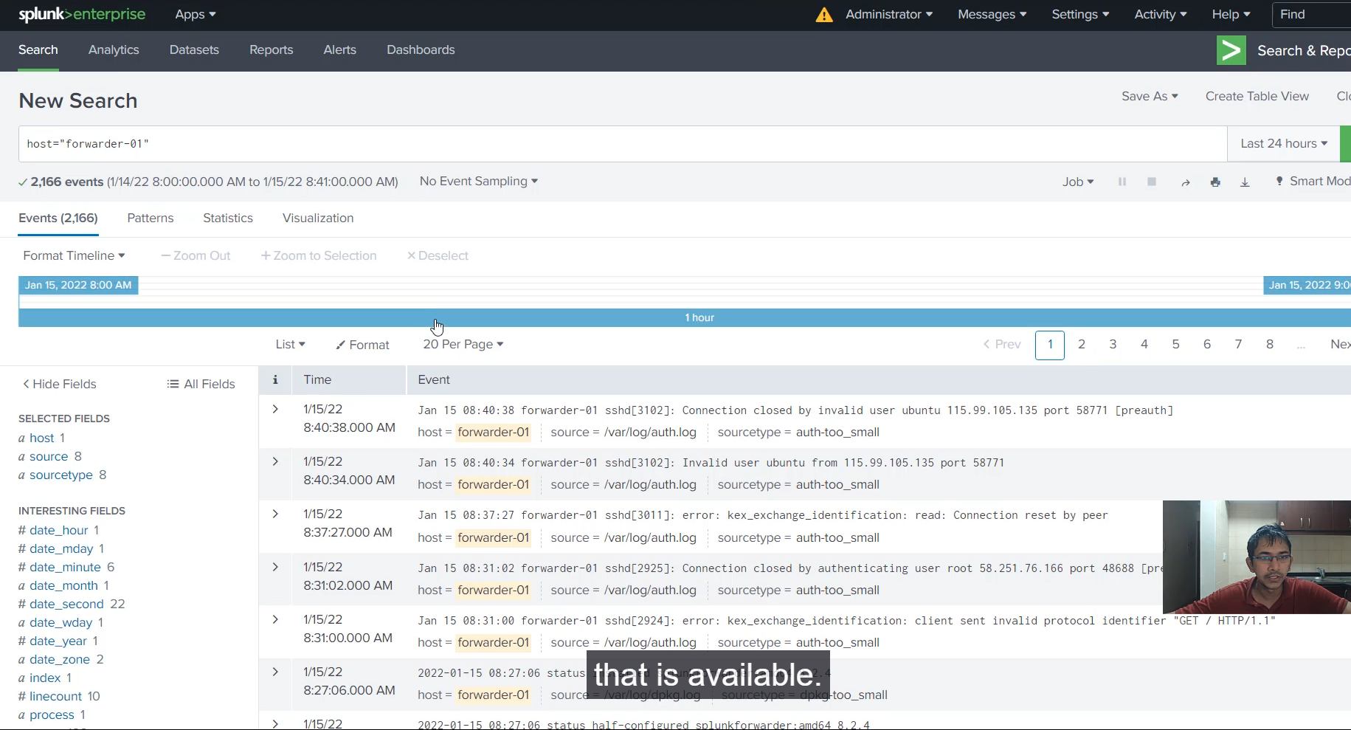

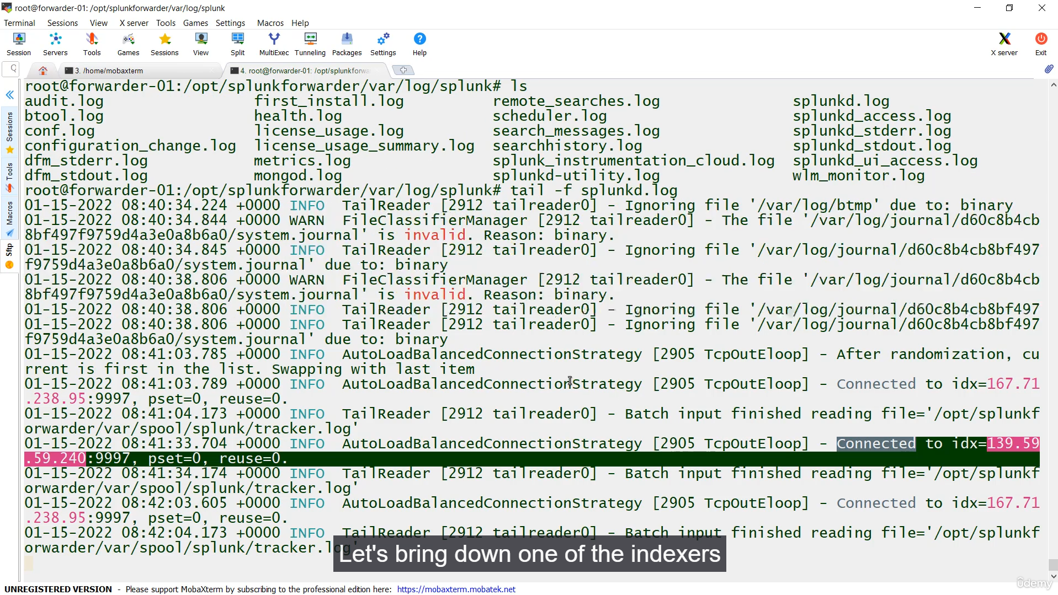

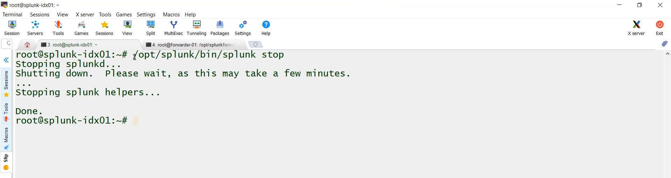

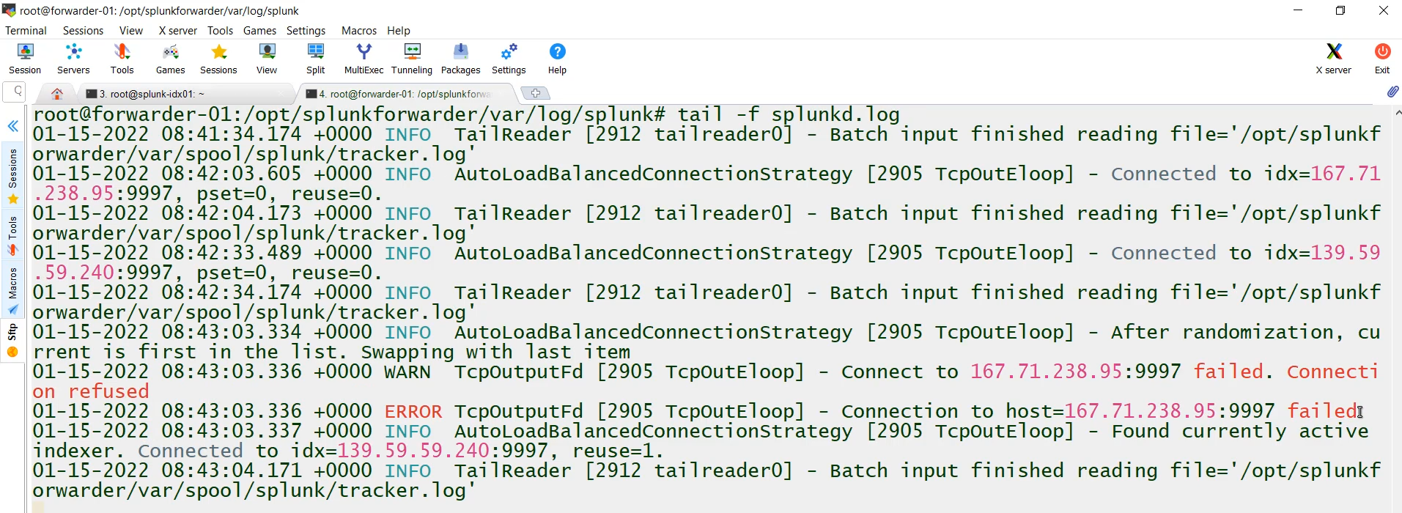

**Universal Forwarder (UF) Log Sending Approaches (Hardcoded Method)**

This video discusses the ways a Universal Forwarder sends logs to a Splunk Indexer Cluster, focusing specifically on the **hardcoded configuration method** (the non-recommended approach).

**1. Two Methods for UF-to-Cluster Connection**

There are two primary ways a Universal Forwarder can send logs to peer indexers:

1. **Indexer Discovery Feature (Recommended):** The UF communicates with the Master Indexer to dynamically discover the current list of available peer nodes. (To be covered in the next video).
2. **Hardcoded Configuration (Demonstrated):** The UF's configuration file explicitly lists the IP addresses of all peer indexer nodes. **This is not the recommended approach.**

**2. The Hardcoded Configuration Approach**

* **Mechanism:** The IP addresses of all peer indexers (IDX01 and IDX02 in the demo) are manually entered into the Universal Forwarder's configuration file, specifically outputs.conf.
* **Log Flow:** The UF selects an IP address from the hardcoded list and begins sending data.
* **Failover:** If one peer indexer goes down (e.g., IDX01), the UF automatically detects the failure and switches to the next indexer on its list (e.g., IDX02) to continue sending logs.

**3. Major Challenge of Hardcoding (Why it's NOT Recommended)**

* **Scalability Issue:** If a new peer indexer node is added to the cluster later, the **thousands of existing Universal Forwarders will not know about it** because their outputs.conf files do not contain the new IP address.
* **Manual Effort:** Updating the configuration across thousands of forwarders for every cluster change (adding or removing a node) is complex and prone to error.

**4. Practical Demonstration Steps**

1. **Setup Indexers to Receive:** The receiving port (9997) was manually enabled on both peer indexers (IDX01 and IDX02).
2. **Configure the UF (Hardcode):**
   * The command splunk add forward-server <IP_ADDRESS>:<PORT> was used for both IDX01 and IDX02.
   * This action created an outputs.conf file in the UF's local directory ($SPLUNK_HOME/etc/system/local/) listing both indexers as destination servers.
3. **Monitor Data:** The UF was configured to monitor a log directory (/opt/splunkforwarder/var/log).
4. **Initial Verification:** Logs from forwarder_01 were successfully received and searchable on the Master Indexer (acting as Search Head).

**5. Testing Hardcoded Failover**

1. **Action:** The **Peer Indexer 1 (IDX01) was manually stopped.**
2. **UF Log Check:** The Universal Forwarder's internal logs (splunkd.log) immediately showed a **"connection to the host... has currently failed."**
3. **UF Switch:** The UF automatically began using the second hardcoded IP (IDX02) to send all subsequent logs.
4. **Final Verification:** A new log entry (a failed login attempt) was generated on the UF, and it was successfully sent to the remaining operational indexer (IDX02) and was **searchable** on the Master Indexer.

**============================================================================**

1. **Implementing Indexer discovery:**

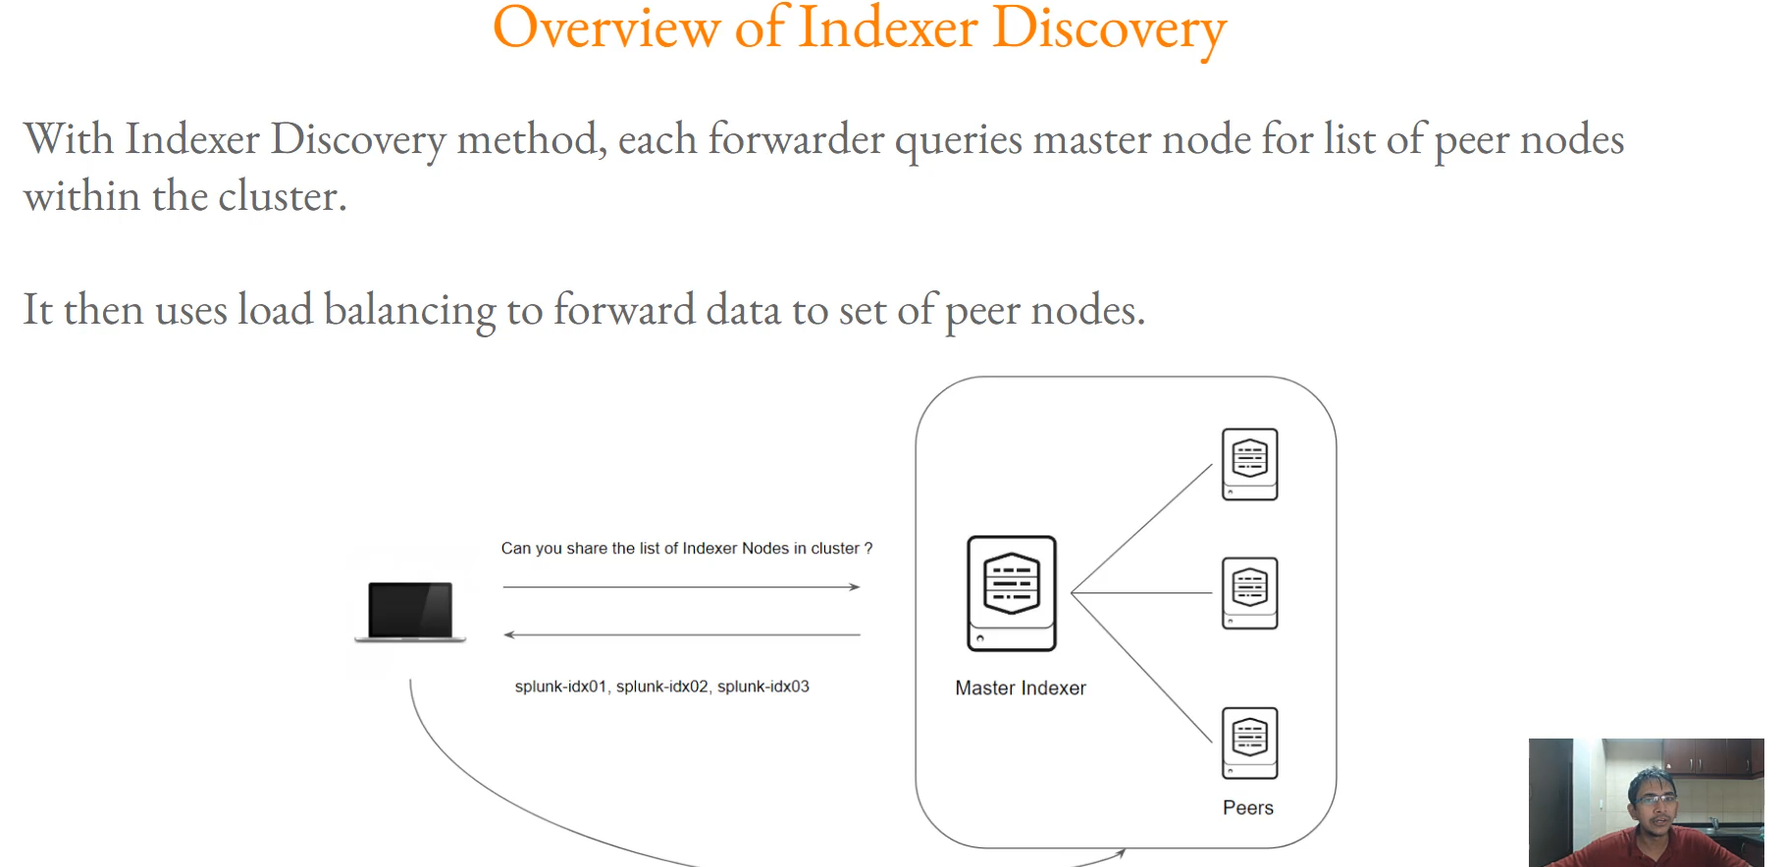

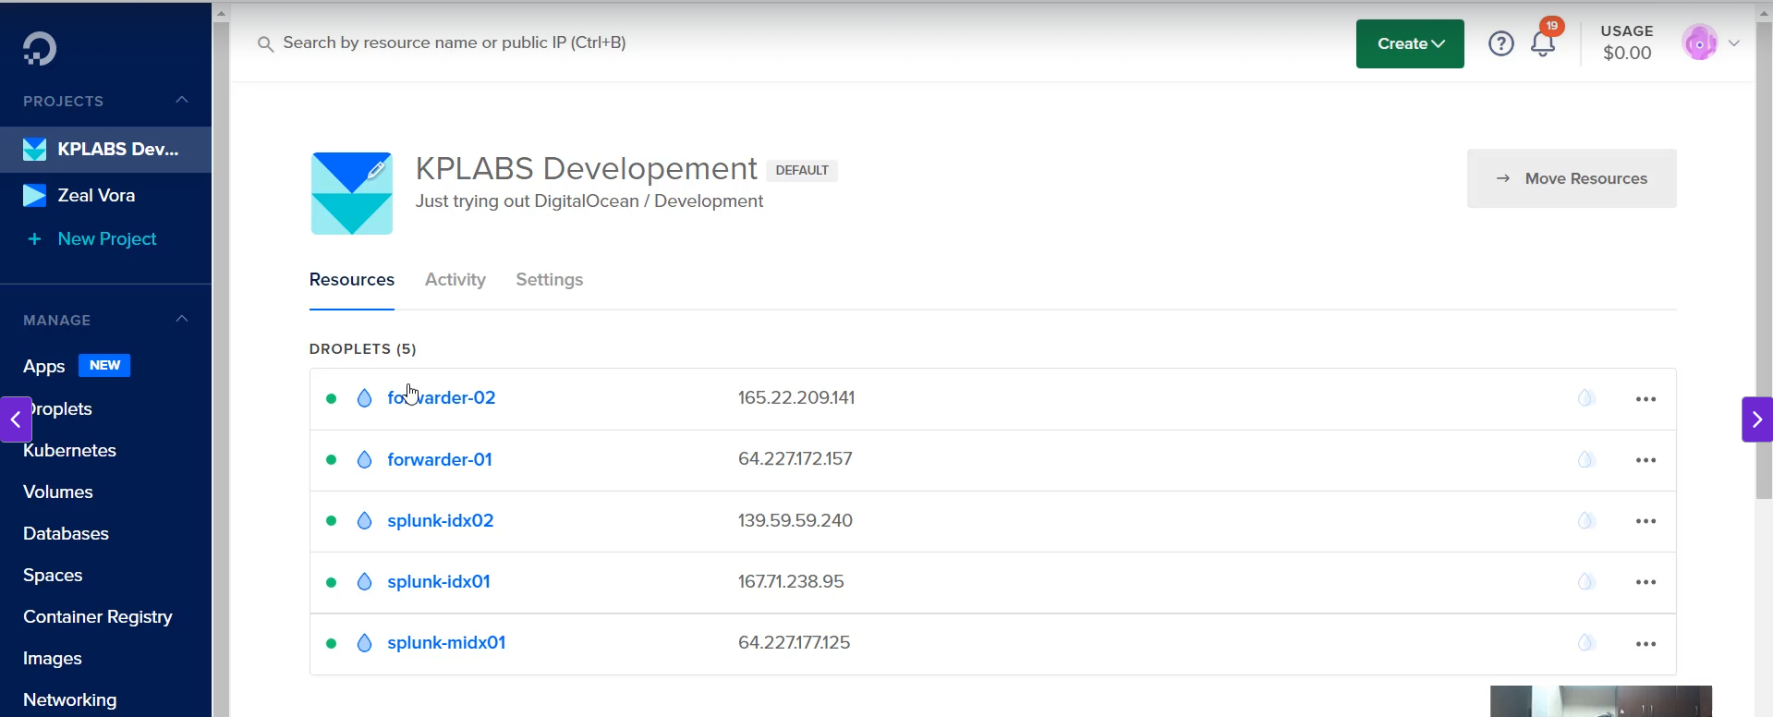

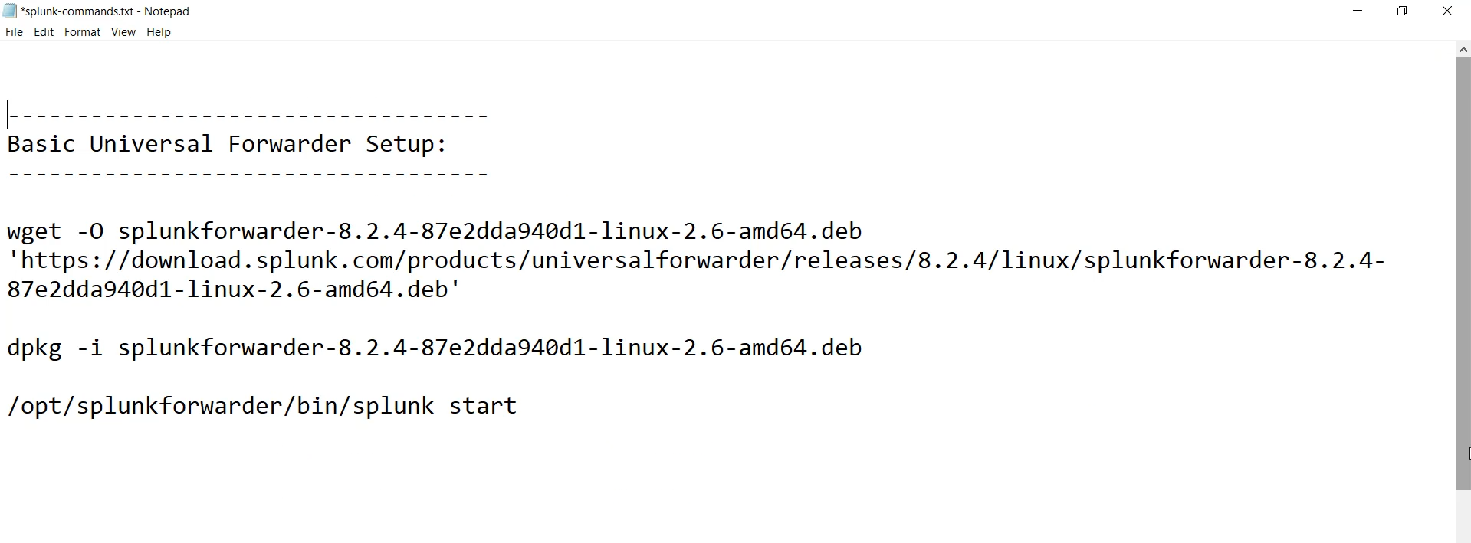

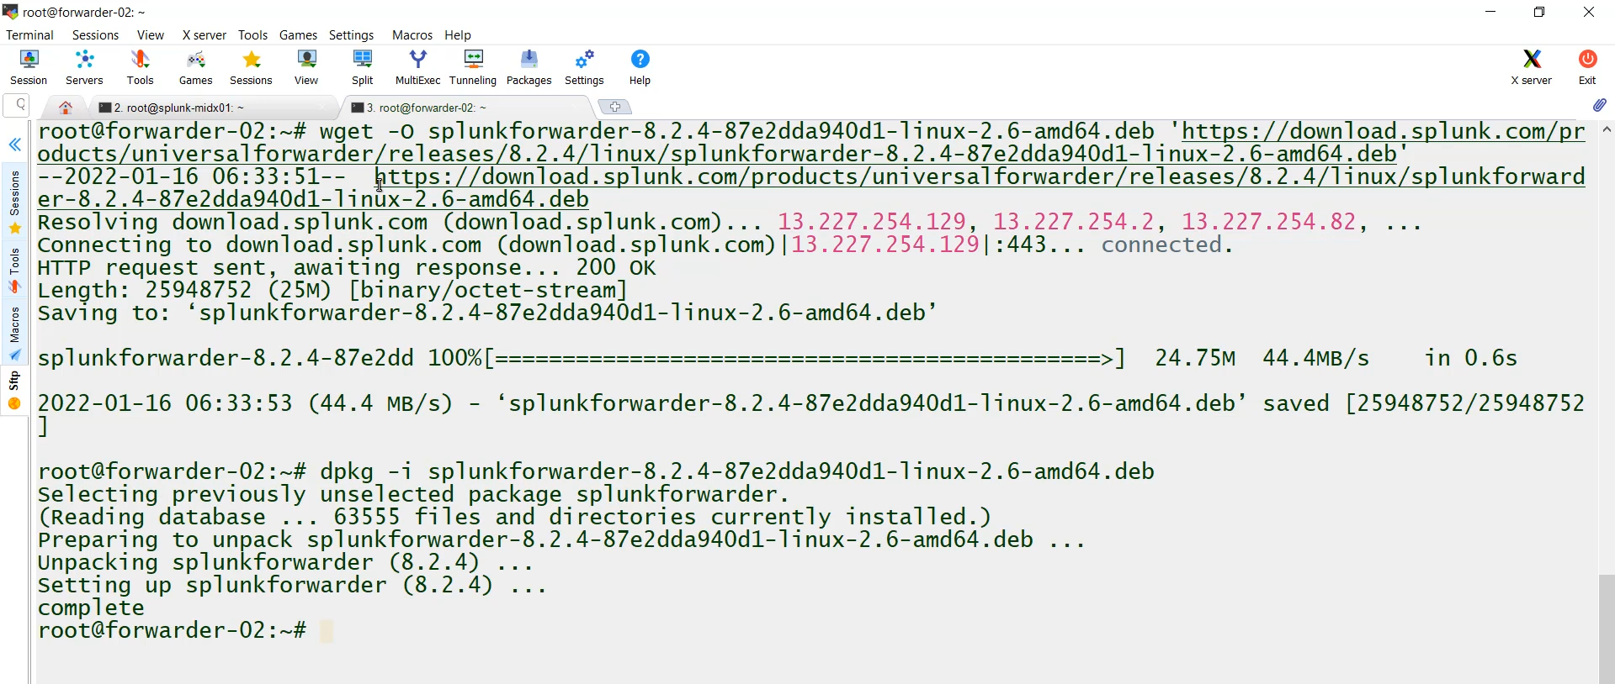

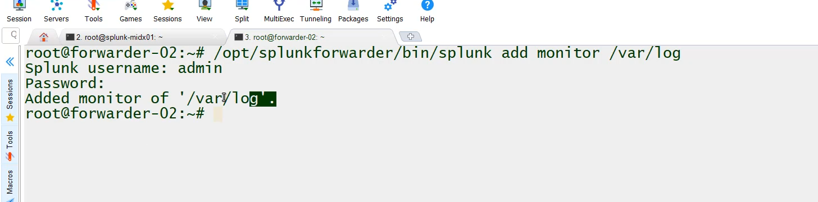

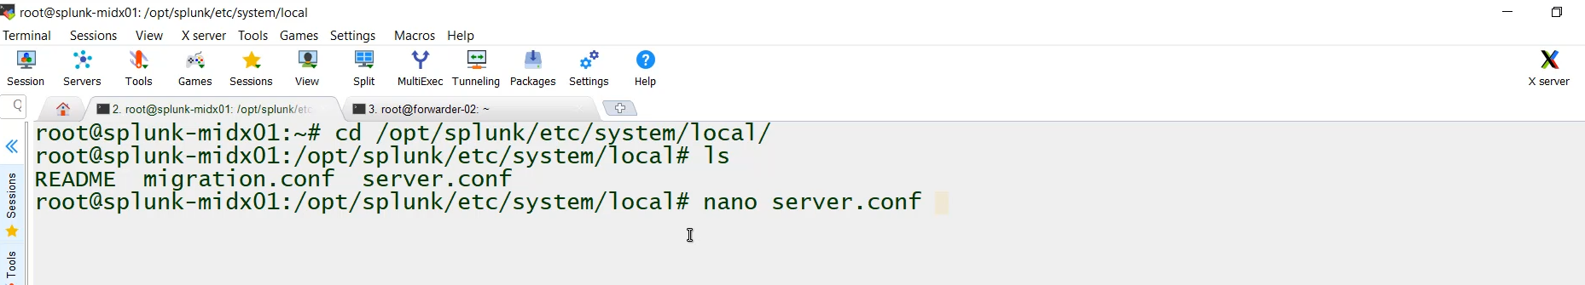

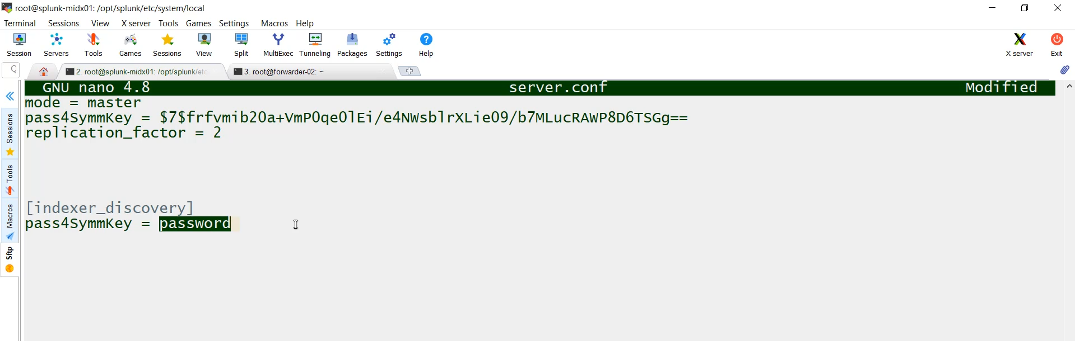

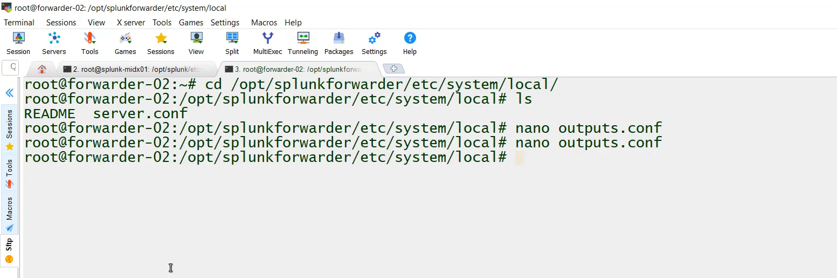

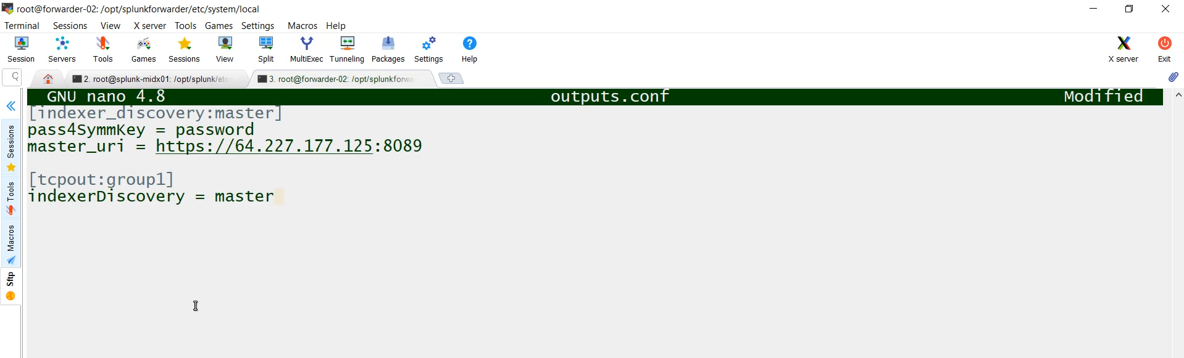

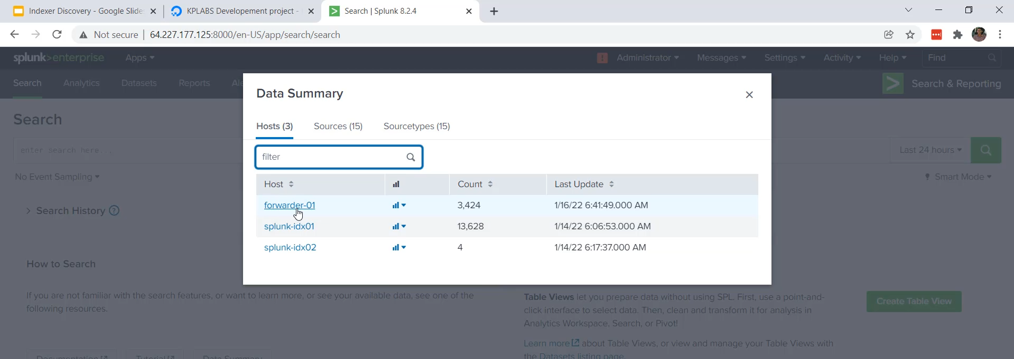

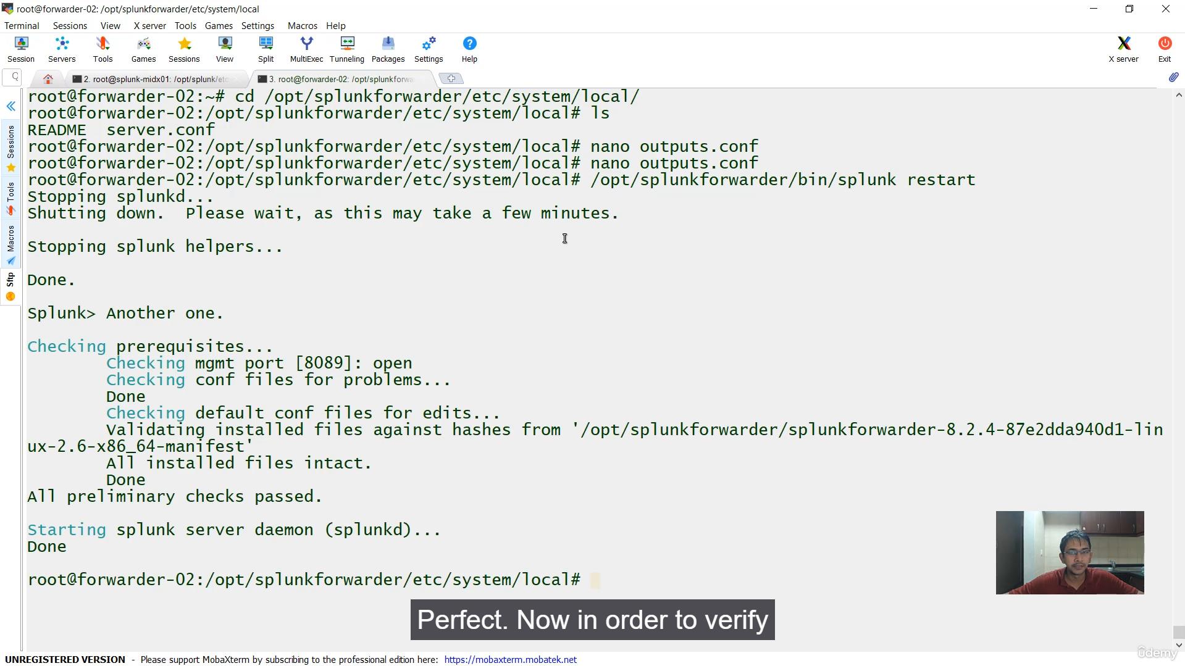

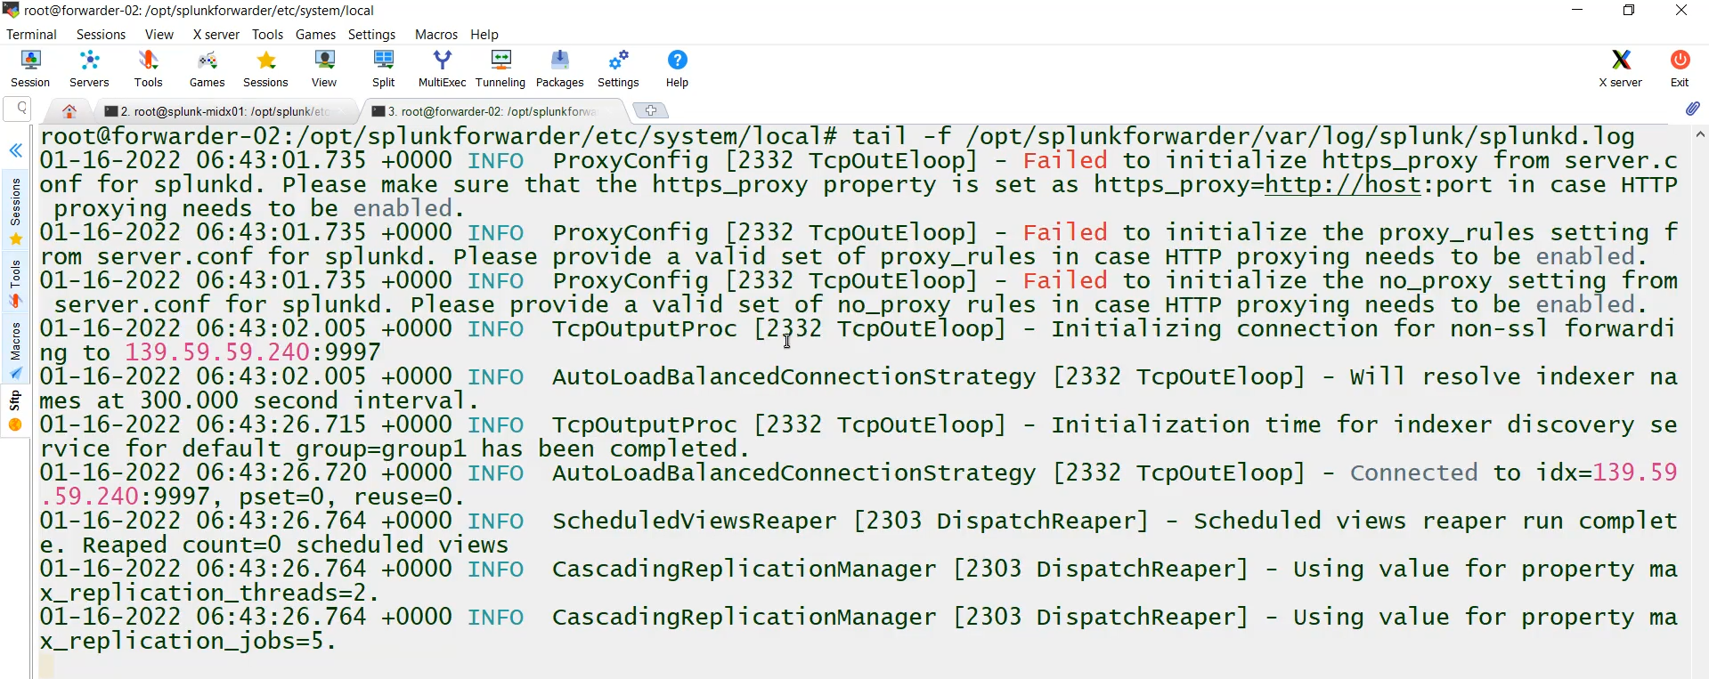

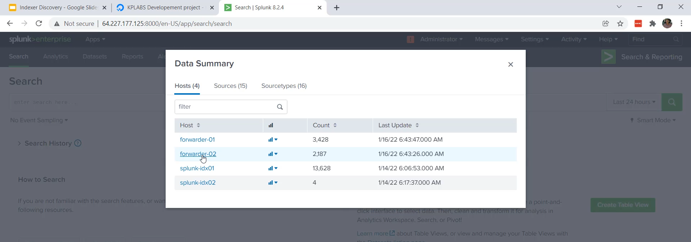

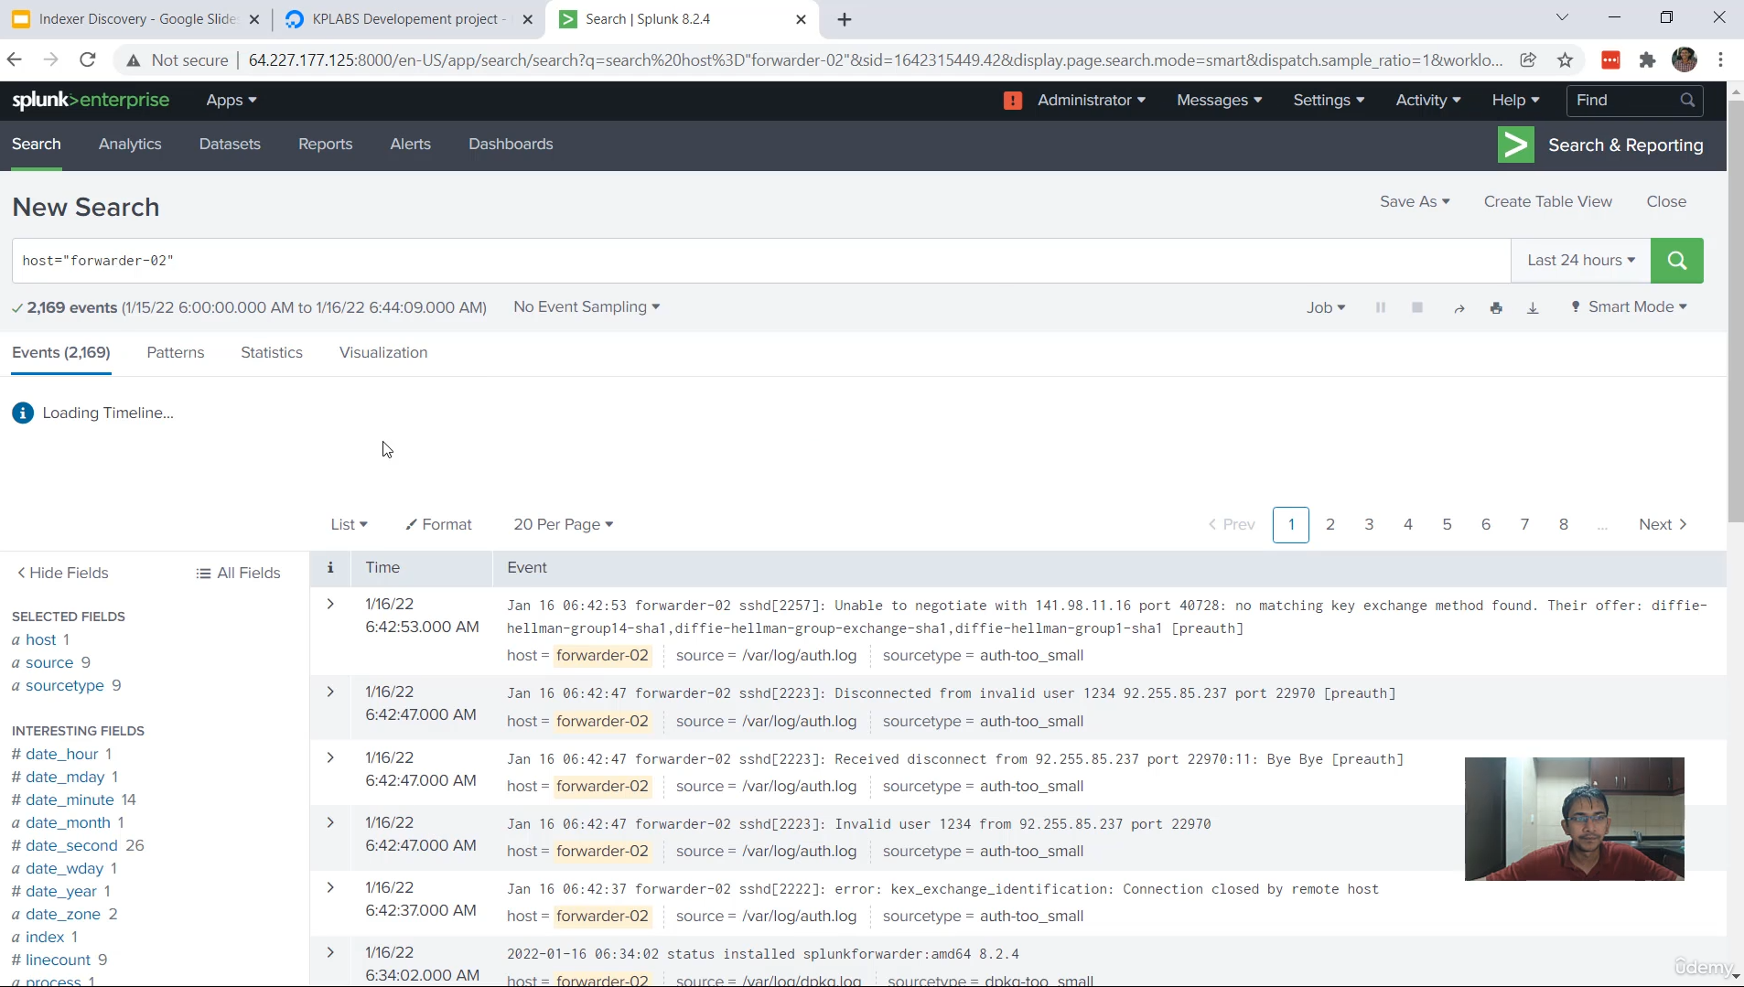

**Splunk Universal Forwarder: Indexer Discovery Method**

This video focuses on **Indexer Discovery**, the recommended and scalable method for Universal Forwarders (UFs) to send logs to an Indexer Cluster. This approach avoids hardcoding indexer IP addresses in the UF configuration.

**1. Core Mechanism of Indexer Discovery**

* **Dynamic List:** The UF does not store the peer indexer IP addresses locally.
* **Query Master:** The Universal Forwarder connects directly to the **Master Indexer** (MIDX).
* **Response:** The Master Indexer returns the current, updated list of all active **Peer Indexer Nodes** (e.g., IDX01, IDX02, IDX03).
* **Load Balancing:** The UF uses this list to forward its data to the peer nodes, automatically using a load-balancing mechanism.
* **Advantage:** If a new indexer is added to the cluster, the UF automatically receives its details on the next query, making the setup highly scalable.

**2. Two Required Configuration Steps**

The Indexer Discovery feature requires configuration on both the Master Indexer and the Universal Forwarder.

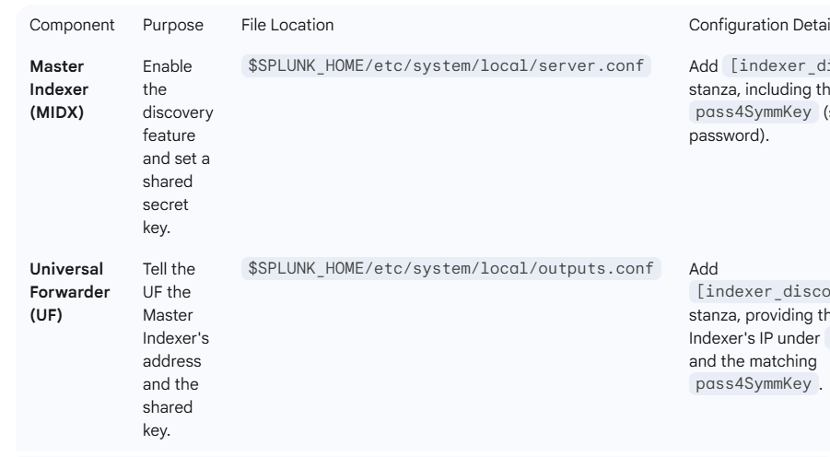

**3. Step-by-Step Implementation**

**Step A: Configure Master Indexer (MIDX)**

1. **Enable Discovery:** Edited the server.conf file on the MIDX.
2. **Set Shared Key:** Added the pass4SymmKey = password within the [indexer_discovery] stanza.
3. **Restart:** Restarted the Master Indexer (splunk restart).
4. **Security Check:** After restart, the plain text password in server.conf was automatically **hashed** by Splunk for security.

**Step B: Configure Universal Forwarder (UF02)**

1. **UF Setup:** Installed the Universal Forwarder on the new forwarder02 server and started it.
2. **Set Monitor:** Configured the UF to monitor a log directory (/var/log).
3. **Create Outputs.conf:** Created the outputs.conf file.
4. **Define Master:** Specified the Master Indexer's IP address under the master_uri in the [indexer_discovery:master] stanza.
5. **Set Shared Key:** Added the matching pass4SymmKey.
6. **Restart:** Restarted the Universal Forwarder (splunk restart).

**4. Verification**

* **UF Log Check:** A tail command on the UF's internal log (splunkd.log) confirmed that it successfully identified and connected to the IP addresses of the peer indexers (e.g., 139 and 161).
* **Search Head Check:** The Master Indexer's Search and Reporting App confirmed that logs from the new **forwarder02** machine were being successfully received, demonstrating the Indexer Discovery feature is fully operational.

Advanced Indexer Discovery Configuration

The standard Indexer Discovery setup ensures a Universal Forwarder (UF) gets the list of available Indexers from the Master Node. The advanced settings, configured primarily in server.conf (on the Master) and outputs.conf (on the UF), allow for fine-tuning this process.

1. Adjusting Polling Frequency

This setting controls how often the Universal Forwarder contacts the Master Indexer to get the updated list of available Peer Nodes.

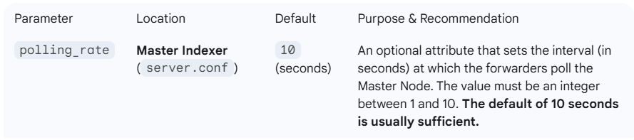

**2. Weighted Load Balancing**

By default, the UF distributes data evenly (round-robin style) across the available Indexers. Weighted Load Balancing allows the UF to send more data to indexers with greater available disk space.

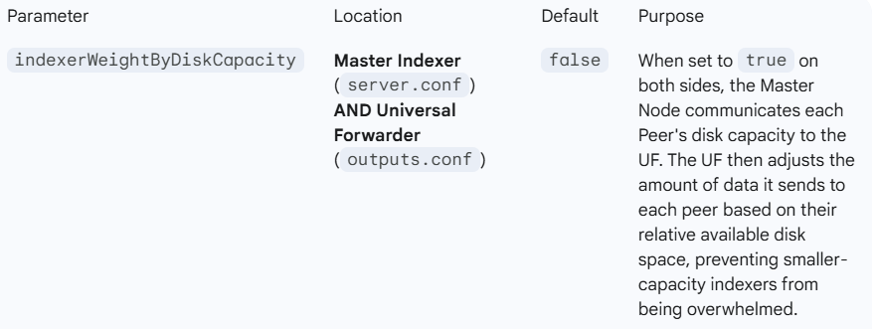

**3. Load Balancing Frequency**

While Indexer Discovery handles *which* indexers are available, a separate setting controls how often the UF switches between the indexers it *is* connected to (as part of its internal load balancing mechanism).

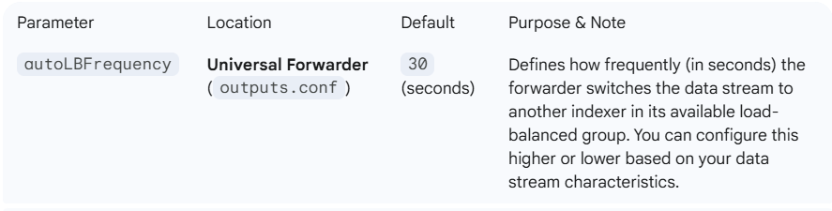

**Note:** Forwarders using Indexer Discovery automatically use load balancing. If one indexer goes down, the forwarder immediately switches to another, regardless of the autoLBFrequency setting.

**4. Indexer Acknowledgment (ACK)**

This is a critical advanced feature for ensuring data integrity, especially when forwarding to a cluster:

* **Mechanism:** When enabled, the indexer sends an acknowledgment (ACK) to the forwarder when data is safely indexed (replicated to the required factor). If the forwarder does not receive the ACK, it assumes the data was lost and re-sends it.
* **Configuration:** You enable this by setting useACK = true in the [tcpout] stanza on the Universal Forwarder's outputs.conf. This is highly recommended for production clusters to guarantee against in-flight data loss.

**\*\*\*\*\*\*\*\*\*\*\*\*\*\*\*\*\*\*\*\*\*\*\*\*\*\*\*\*\*\*\*\*\*\*\*\*\*\*\*\*\*\*\*\*\*\*\*\*\*\*\*\*\*\*\*\*\*\*\*\*\*\*\*\*\*\*\*\*\*\*\*\*\*\*\*\*\*\*\*\*\*\*\*\*\*\*\*\*\*\*\*\*\*\*\*\*\*\*\*\*\*\*\*\*\*\*\*\*\*\*\*\*\*\*\*\*\*\*\*\*\*\*\*\*\*\*\*\*\*\*\*\*\*\*\*\*\*\*\*\*\*\*\*\*\*\*\*\*\*\*\*\*\*\*\*\*\*\*\*\*\*\*\*\*\*\*\*\*\*\*\*\*\*\*\*\*\*\*\*\*\*\*\*\*\*\*\*\*\*\*\*\*\*\*\*\*\*\*\*\*\*\*\*\*\*\*\*\*\*\*\*\*\*\*\*\*\*\*\*\*\*\*\*\*\*\*\*\*\*\*\*\*\*\*\*\*\*\*\*\*\*\*\*\*\*\*\*\*\*\*\*\*\*\*\*\*\*\*\*\*\***